Section 2

## Creating and Connecting Vue App Instances

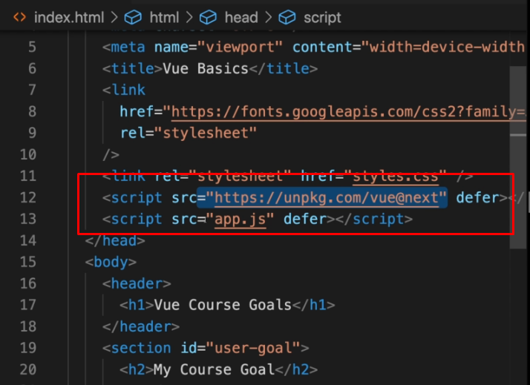



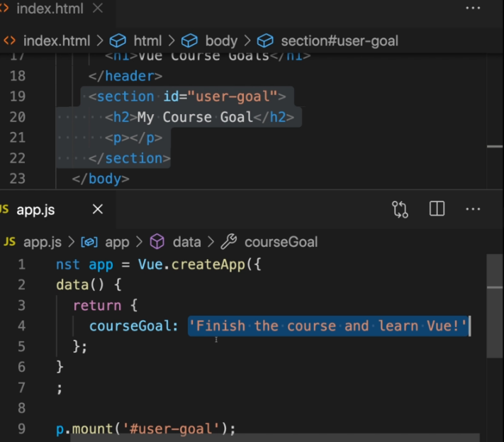

## Interpolation and Data Binding

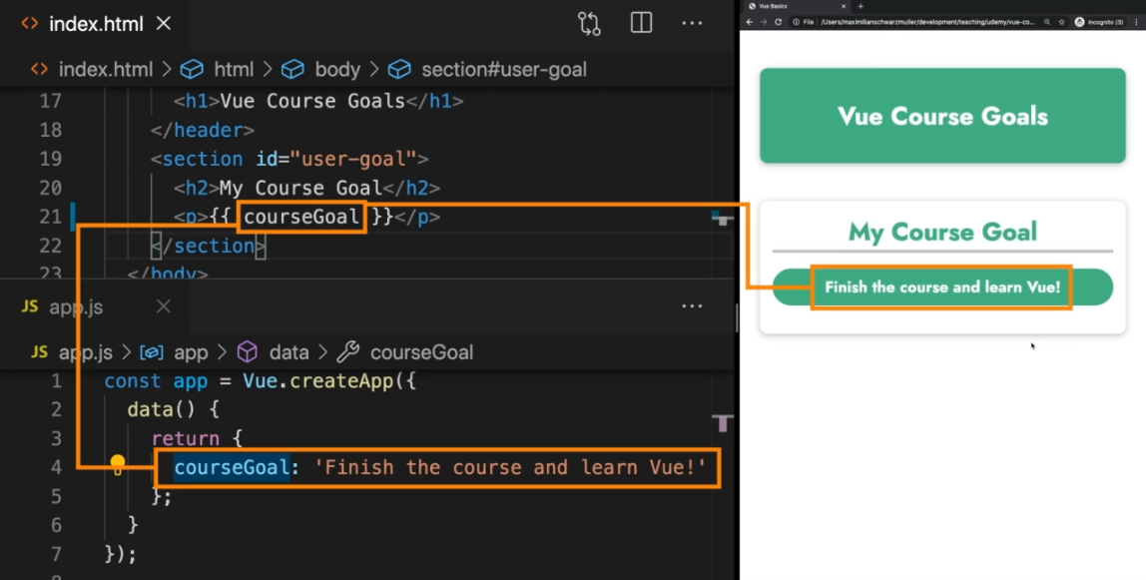

## Binding Attributes with the "v-bind" Directive

v-bind tells Vue to bind, so to set the value of something of an attribute on a html element  
  
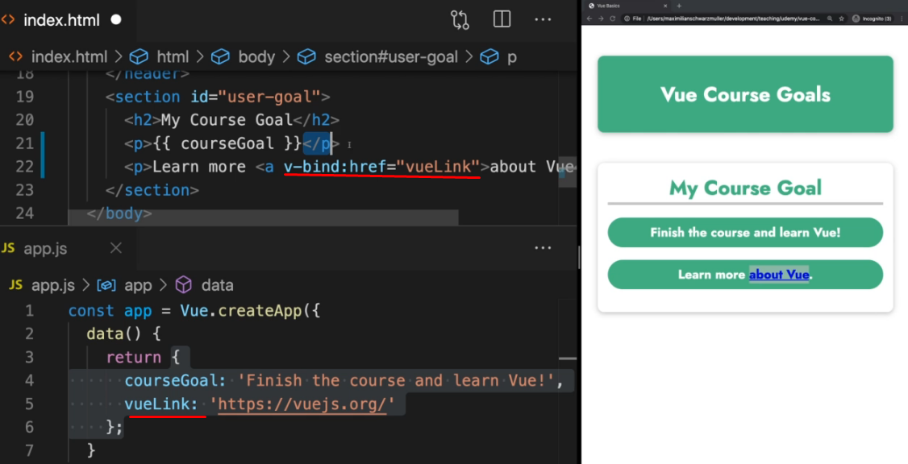

## Understanding Event Binding

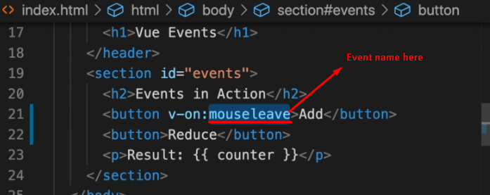

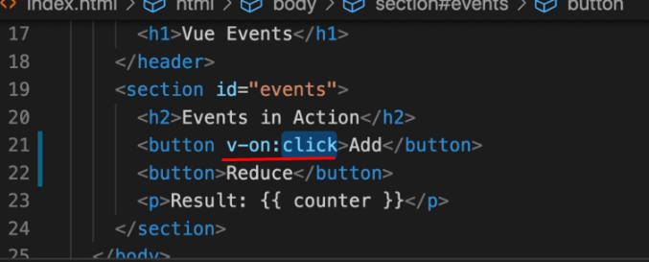



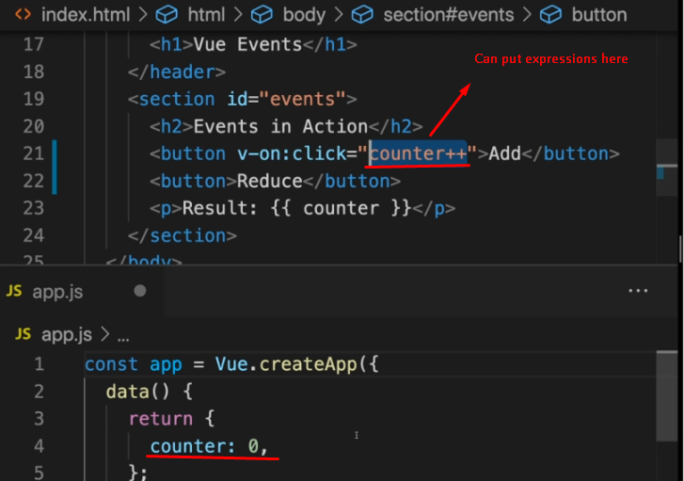

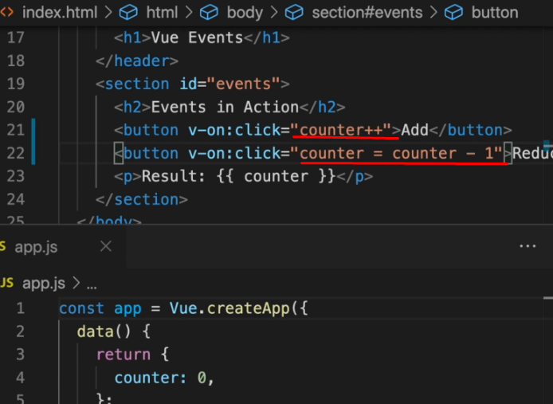

Vue.createApp({

data() {

return {

}

},

watch: {

},

computed: {

},

methods: {

}

}).mount('#assignment');

**v-bind** is helpful for **setting the value** of an **attribute**

<img **v-bind**:src="variable" />

**v-on** for **adding** an **event listener** to element

<button **v-on**:click="function_name">Click me</button"

<input type="text" **v-on**:input="" />

## Using the Native Event Object

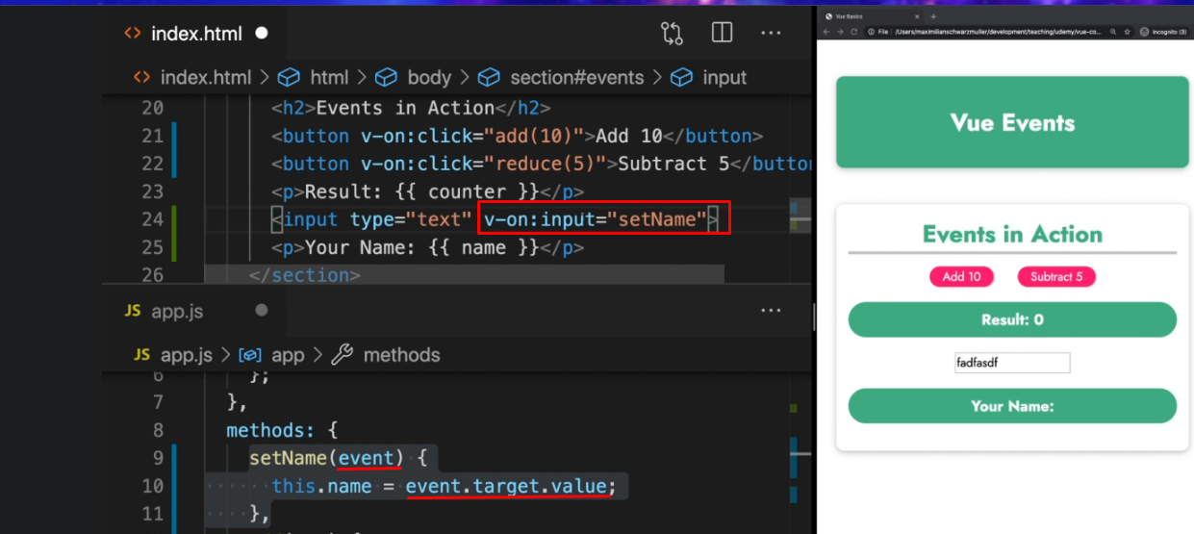

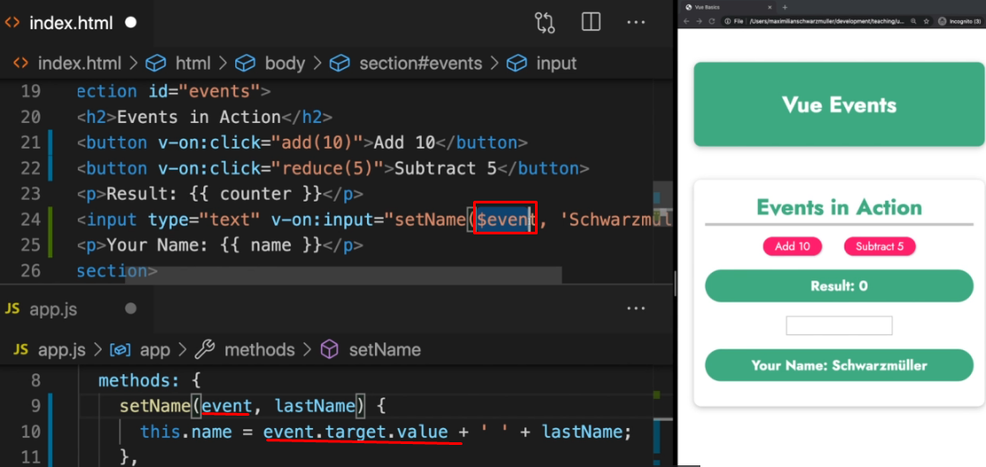

## Event modifiers

<form action="" v-on:submit**.prevent**="submitForm">

<form action="" v-on:submit**.stop**="submitForm"> //for stop propagation

<button v-on:click**.right**="subtract(5)">Remove</button> //click activating only with right click of the mouse

<input

type="text"

v-on:input="setName($event, 'Family')"

v-on:keyup**.enter**="confirmInput"

/>

Two way data binding - v-model

<input *type*="text" *v-model*="name" />

V-model is a shortcut on v-bind and v-on:input



//Methods are not a good solution for outputting

<p>Your Name: {{ outputFullName() }}</p>

Because they are called by Vue everytime when rerender element of the page. No matter that another part which not use the method is changed and re-rendered, the method always will be executed, which is not good from the performance point of view. This is because Vue don’t know if the method contains part of the re-rerendered element. It don’t know what the method do, so it  
Just execute it every time when something is changed and re-rendered.

## 

## 

## Computed properties

They are like methods but with one important difference - Vue will

be aware of their dependencies and only re-execute them if one of the dependencies changed.

Computed is the third big configuration option for the app we create. The fist one is data, the second one was methods and the third one is computed

const app = Vue.createApp({

data() {

return {

counter: 0,

name: ''

};

},

computed: {},

methods: {

outputFullName() {

console.log('Running again');

if (*this*.name === '') return '';

return *this*.name + ' ' + 'Schwarzmuller';

},

setName(*event*) {

*this*.name = *event*.target.value;

},

add(*num*) {

*this*.counter = *this*.counter + *num*;

},

reduce(*num*) {

*this*.counter = *this*.counter - *num*;

// this.counter--;

},

In computed we define a bunch of methods just like in methods configuration property. But the methods we define in computed will be called and executed differently.

## Watchers

Basically a function you can tell Vue to execute when one of its dependencies changed. That sounds like a computed properties and you can use watchers instead of computed properties

const app = Vue.createApp({

data() {

return {

counter: 0,

name: '',

fullName: ''

};

},

watch: {

name() { } //now the connection between property name and the method is established.

//thats mean that if the name property is changed, then the name method will be re-executed

},

computed: {

// fullname() {

// console.log('Running again');

// if (this.name === '') return '';

// return this.name + ' ' + 'Schwarzmuller';

// }

},

methods: {

That is how watchers work. You repeat another data or computed property name in a watcher method, as a method name there and when you do that watcher method will be executed automatically by Vue, whenever a property of that name, changes.

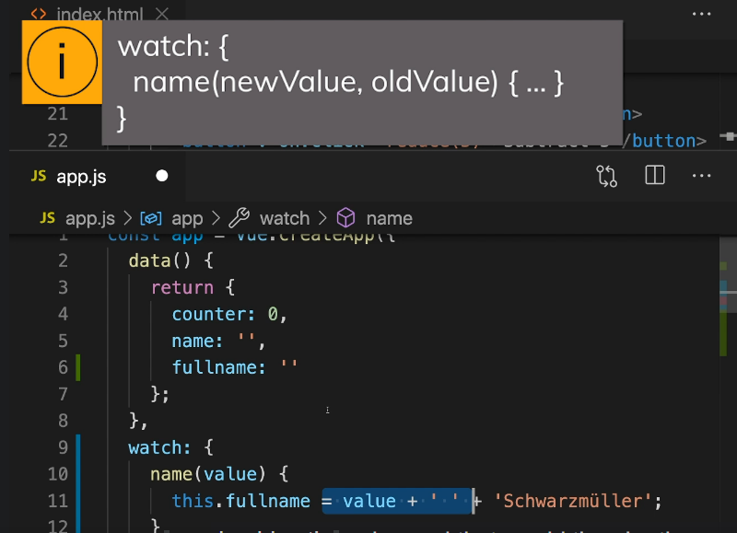

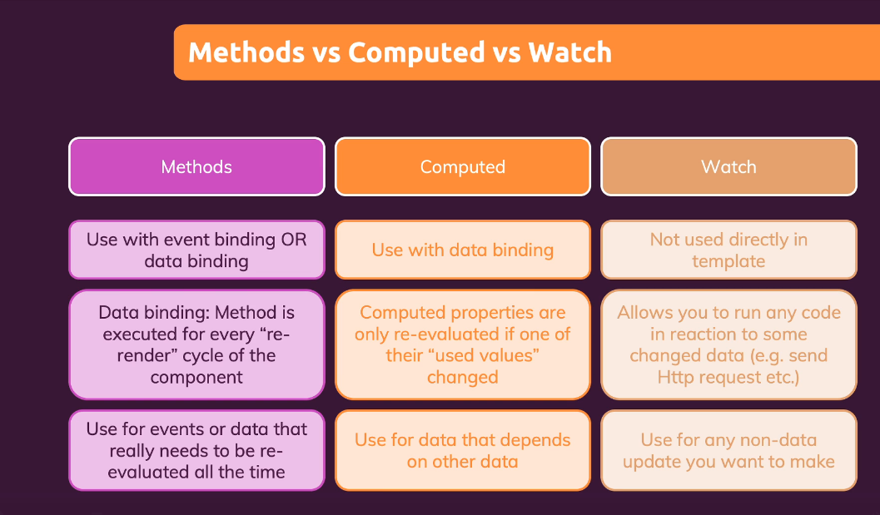

## Shorthands for v-on and v-bind

v-on => @

v-bind => :

v-model => has no shorthad

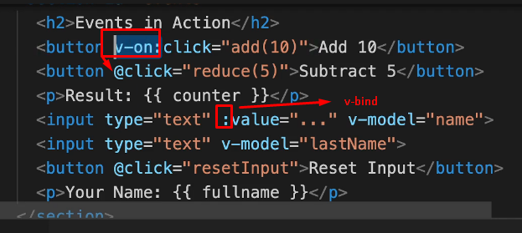

## Adding CSS styles dynamically

<div

*:style*="{borderColor: boxASelected ? 'red' : '#ccc'}"

*@click*="boxSelected('A');"

></div>

<div

*class*="demo"

*:class*="{demo: true, active: boxASelected}"

*@click*="boxSelected('B');"

></div>

### Top example optimized

<div

*class*="demo"

*:class*="{active: boxASelected}"

*@click*="boxSelected('A');"

></div>

### Dynamically binding a class

*:class*="{active: boxASelected}"

### Dynamicay bind a class with computed property

In JS file

const app = Vue.createApp({

data() {

return {

boxASelected: false,

boxBSelected: false,

boxCSelected: false

}

},

computed: {

boxAClasses() {

return { active: *this*.boxASelected };

}

},

In html

<div *class*="demo" *:class*="boxAClasses" *@click*="boxSelected('A');"></div>

Another syntax

<div

*:class*="['demo', {active: boxBSelected }]"

*@click*="boxSelected('B');"

></div>

## Section 2 Summary

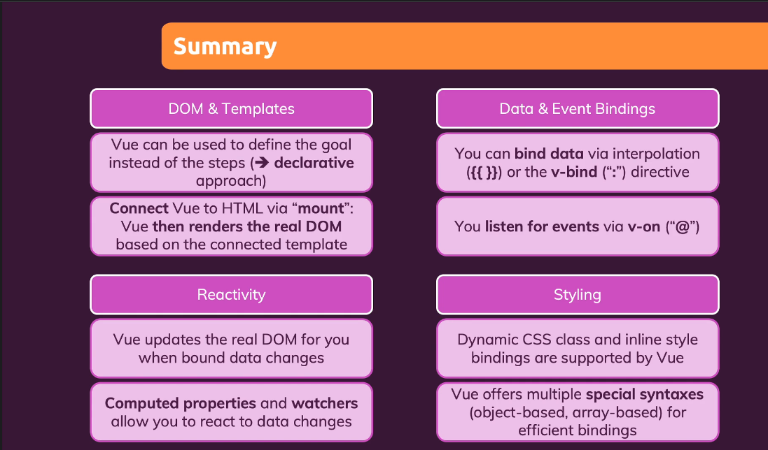

Section 3

# Rendering Content Dynamically

v-if

<p *v-if*="goals.length === 0">

No goals have been added yet - please start adding some!

</p>

<ul>

<li>Goal</li>

</ul>

v-else /must be directly after v-if/

<p *v-if*="goals.length === 0">

No goals have been added yet - please start adding some!

</p>

<ul *v-else*>

<li>Goal</li>

</ul>

v-else-if

<p *v-if*="goals.length === 0">

No goals have been added yet - please start adding some!

</p>

<ul *v-else-if*="goals.length > 0">

<li>Goal</li>

</ul>

v-show

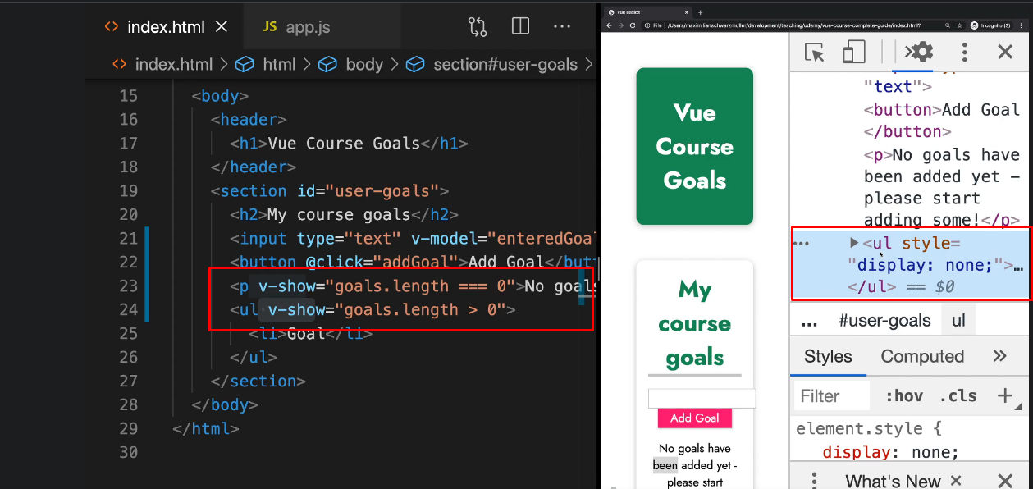

v-for

<p *v-if*="goals.length === 0">

No goals have been added yet - please start adding some!

</p>

<ul *v-else*>

<li *v-for*="goal in goals">{{goal}}</li>

</ul>





Loop through object









Looping through range of numbers



Removing element

<p *v-if*="goals.length === 0">

No goals have been added yet - please start adding some!

</p>

<ul *v-else*>

<li *v-for*="(goal, index) in goals" *@click*="removeGoal(index)">

{{goal}} - {{index}}

</li>

</ul>

# Lists & Keys

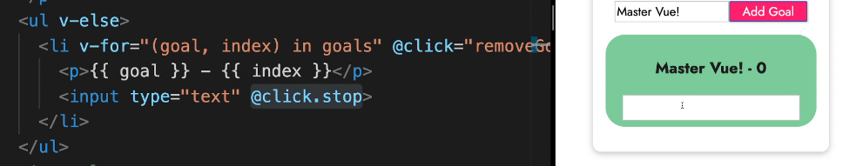

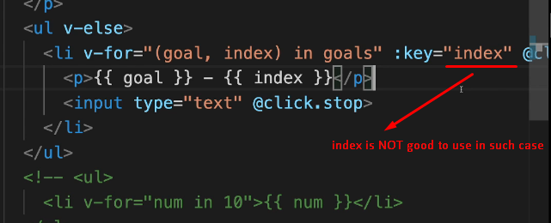

**In this case must be better to use goal. In real app the best variant is tho put id there  
  
**

# 

# Section 3 Summary

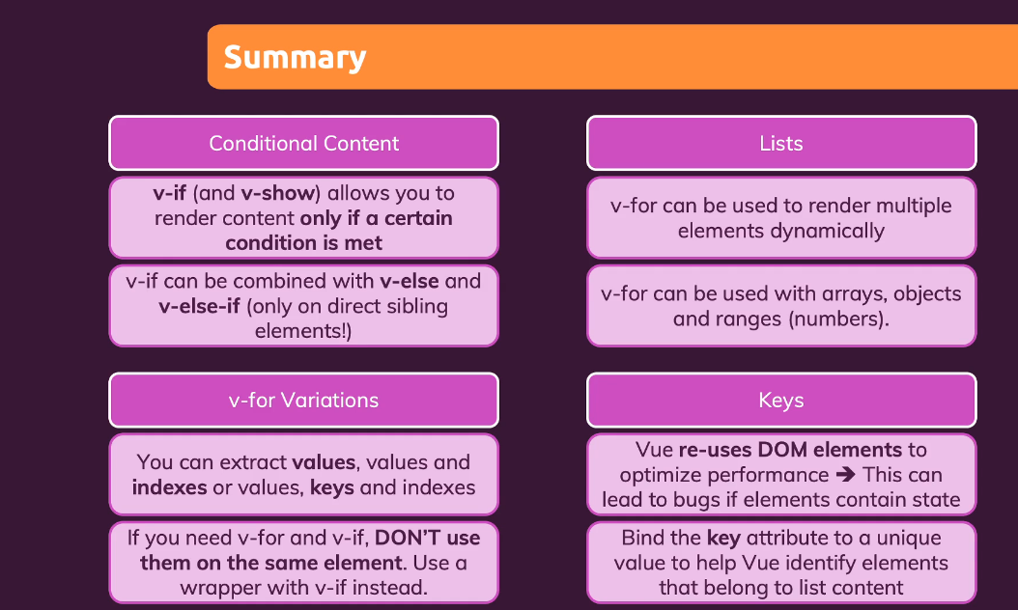

Section 5

Vue is using Proxing Pattern to understand when and what is changed. Something like that

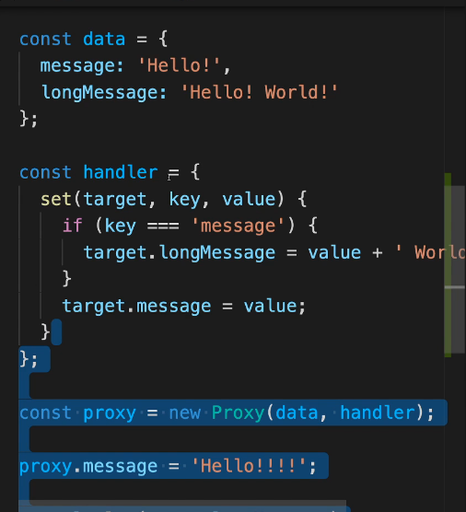

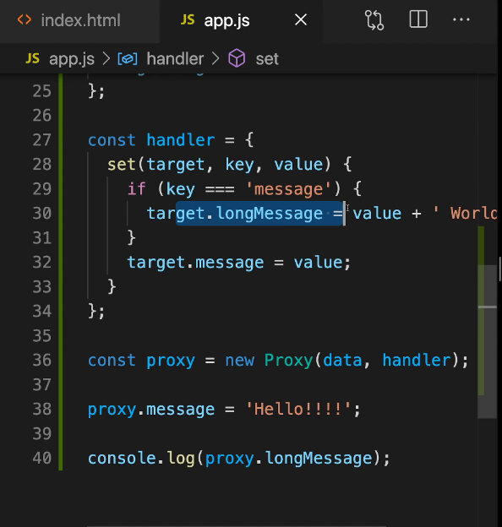

Vue has a feature which allow to us to retrieve the value from dom elements when you need them instead all of the time like @input for example. That feature is called Refs

Old way

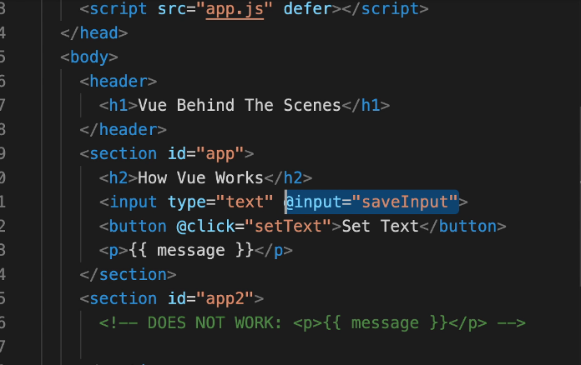

With refs  
  
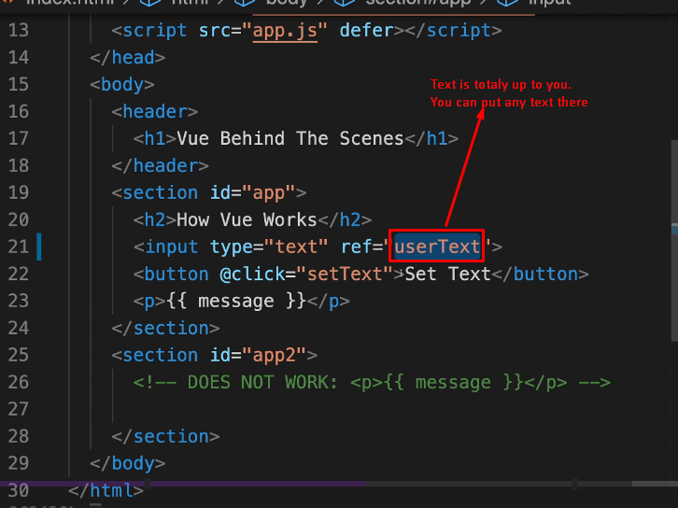

You can add refs to any html elements.

Vue detects such refs and stores them internally. It basically memorize that you want access to the element. And the javascript code can gain access to this element.

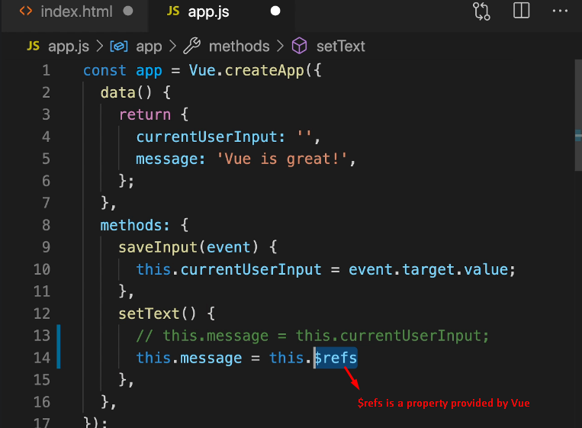

$refs is an object full with key-value pairs, where the keys are the refs identifiers (for example the ref identifier in the image 2 from section 5 is the value userText.)

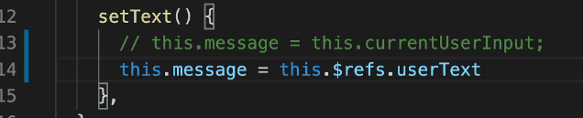

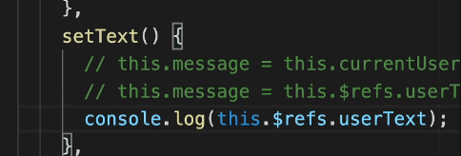

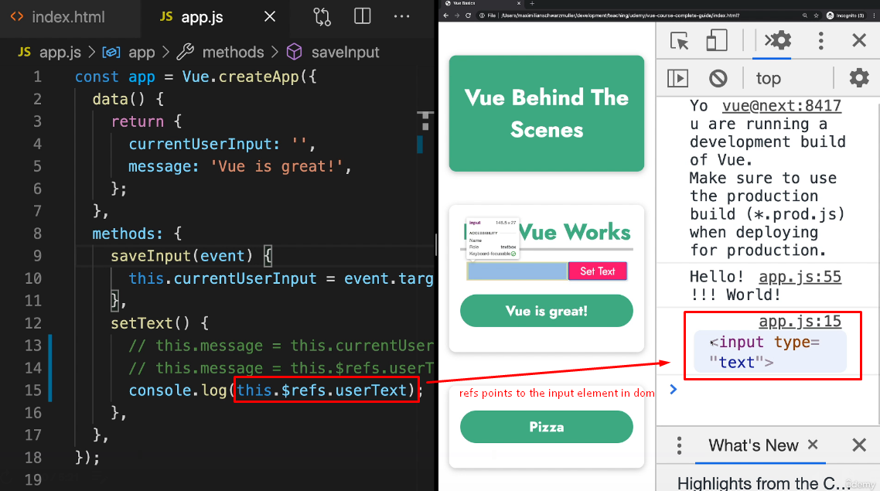

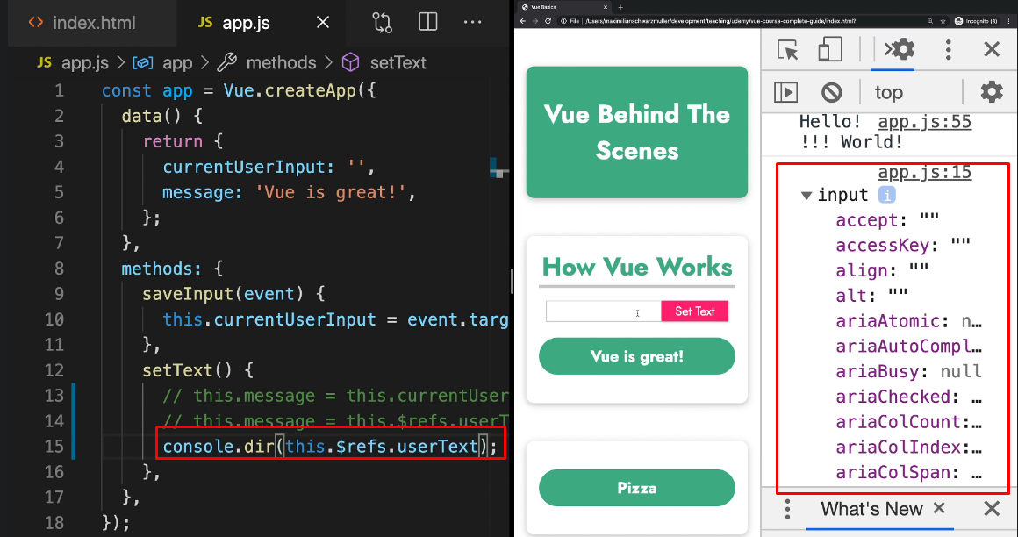

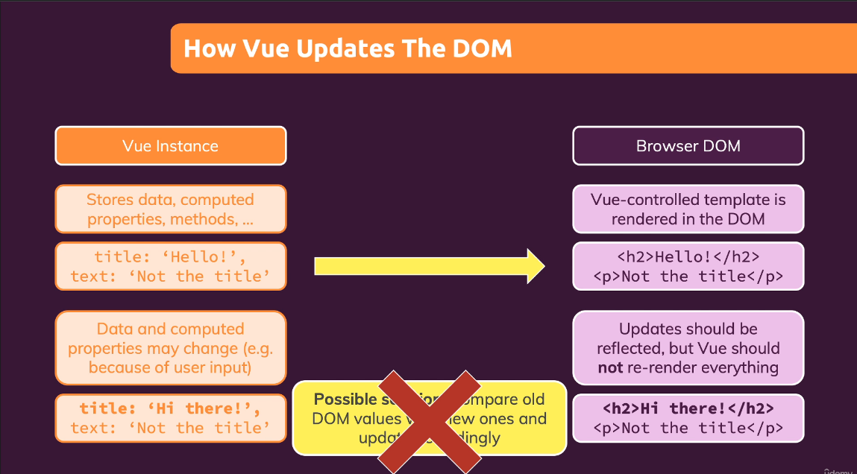

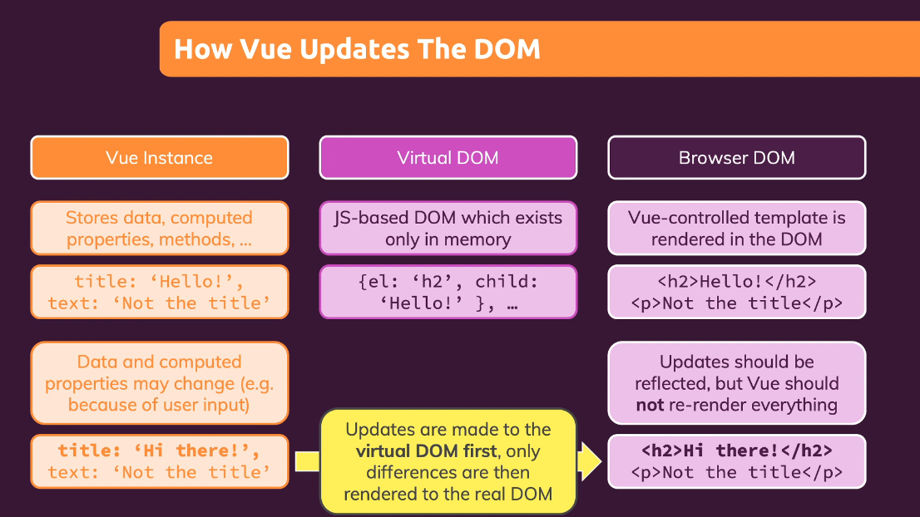

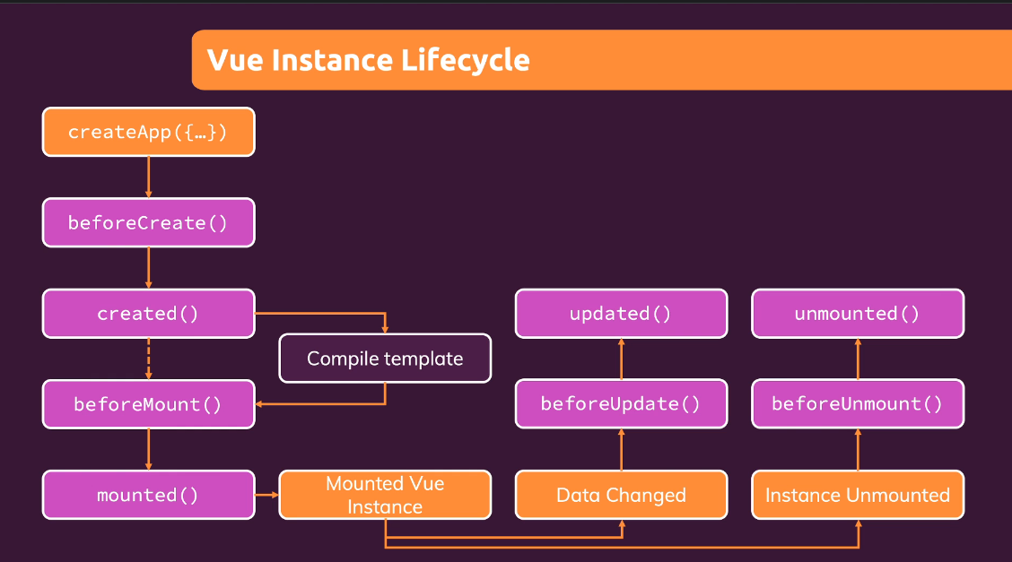

Section 6

app.component(identifier/name, config)

A component is a basically like a html element. It accept two parameters - identifier e.g. name of the component and a config object. A simple rule to name your component is to use multi-word component names, so custom html to not clash with in-build in html elements which are single word.

app.component('friend-contact', {})

A Vue component is essentially just another Vue app. Just an app belong to another app.

Example:

App.js file

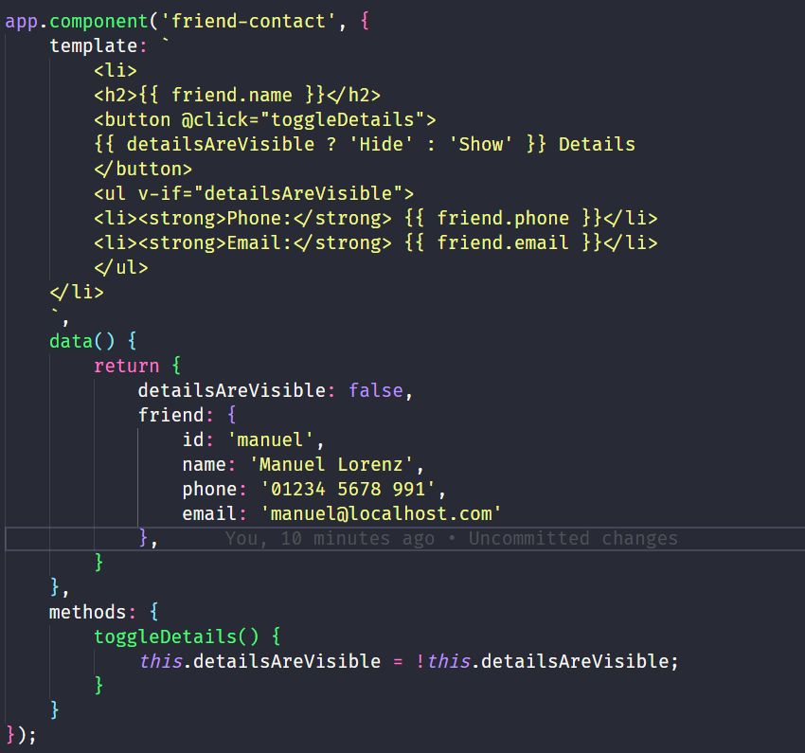

Index.html

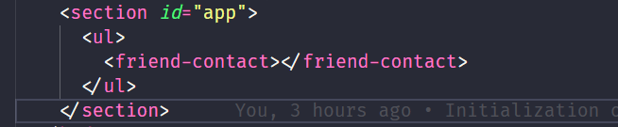

Section 7

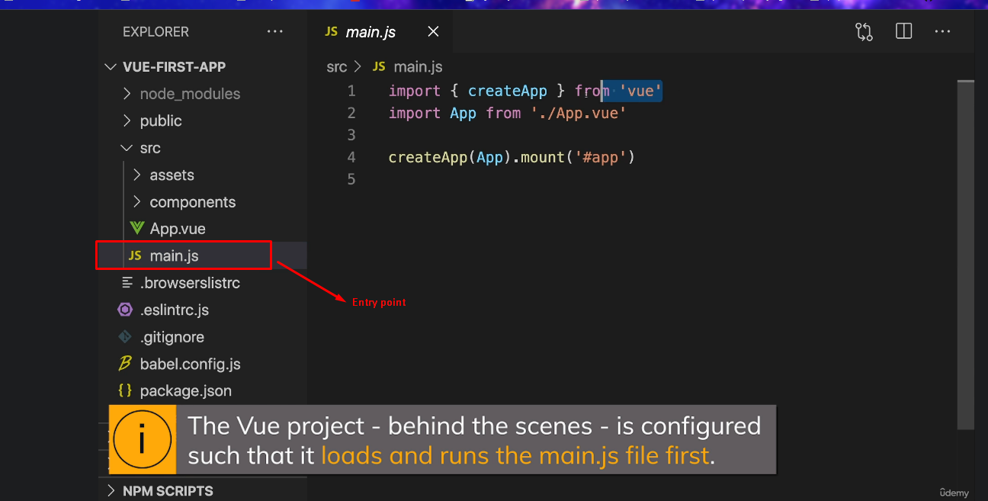

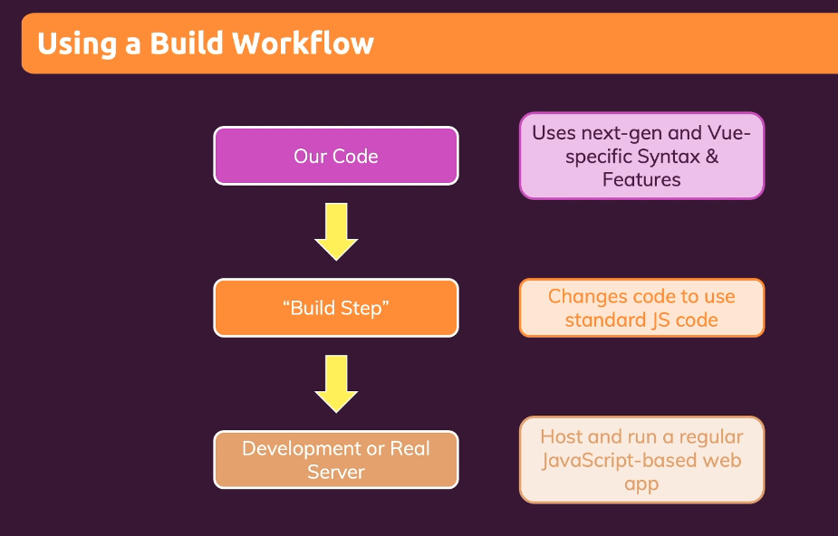

## CREATING A BASIC VUE APP

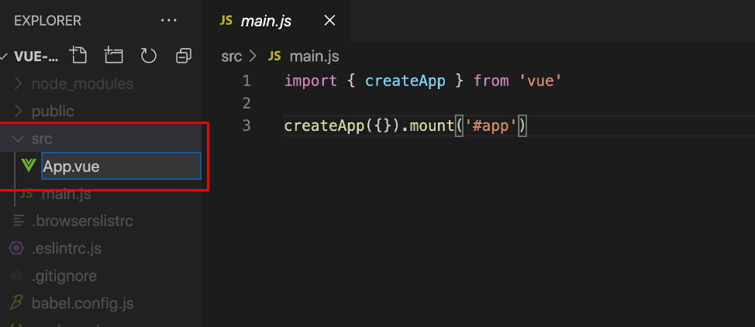

You don’t need to name it App, but it is a convention to name your main file which holds your main vue app configuration App.vue

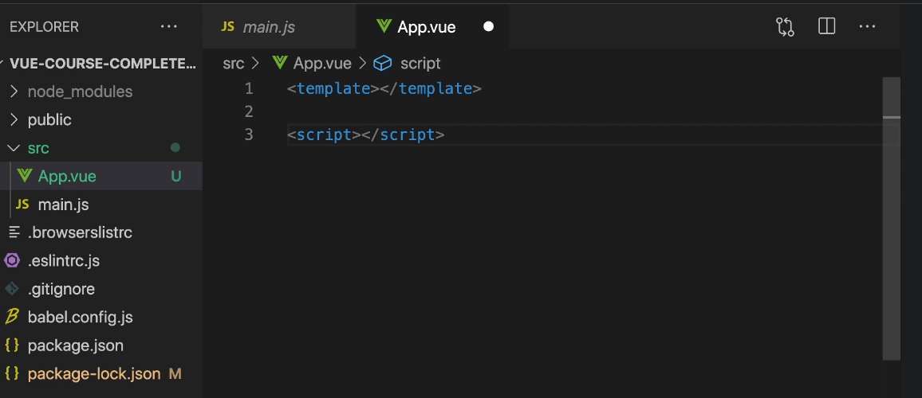

In script tags we provide the configuration for our vue app

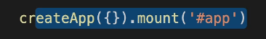

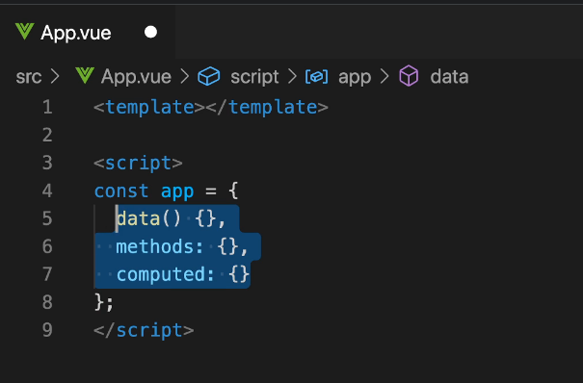

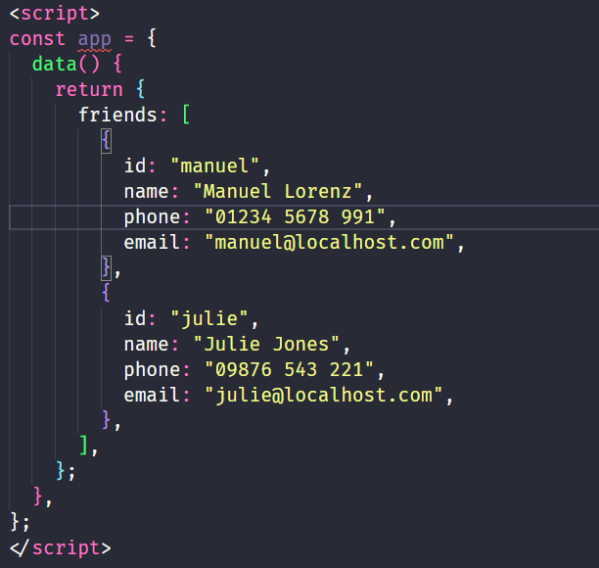

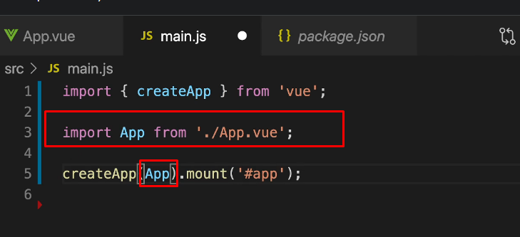

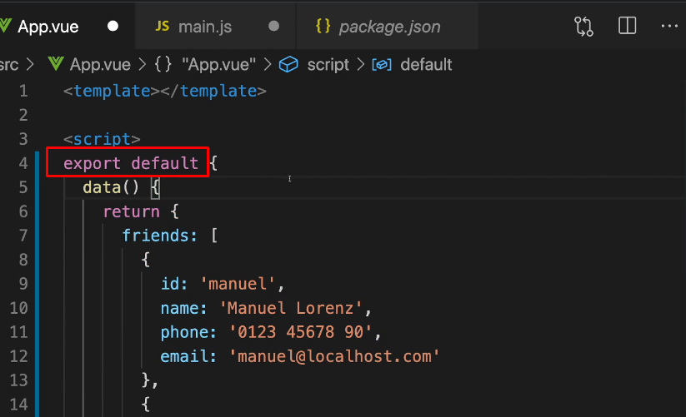

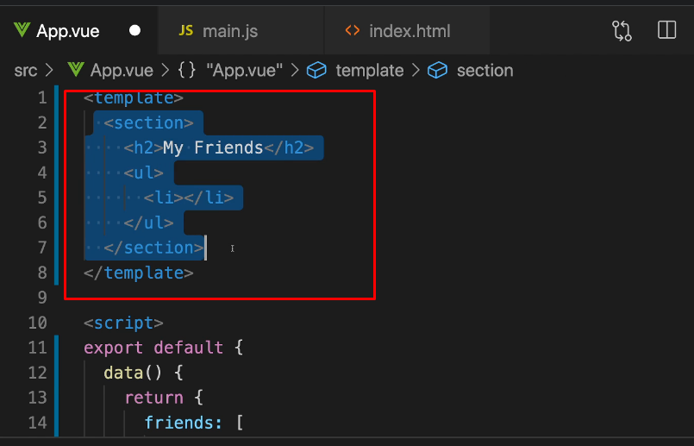

## 

## ADDING A FIRST COMPONENT

There is a convention that you must create a folder named components in your source folder (src) to hold your components

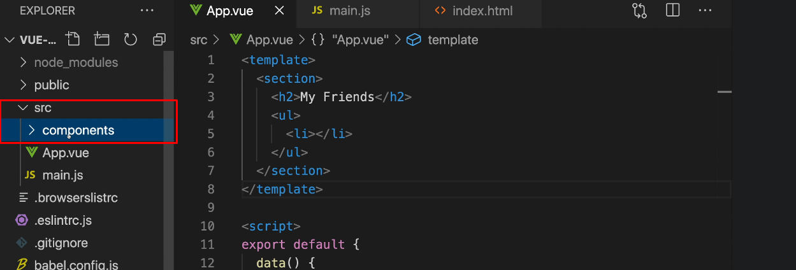

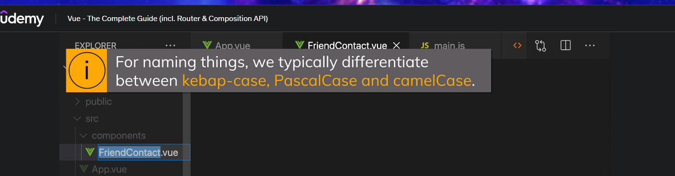

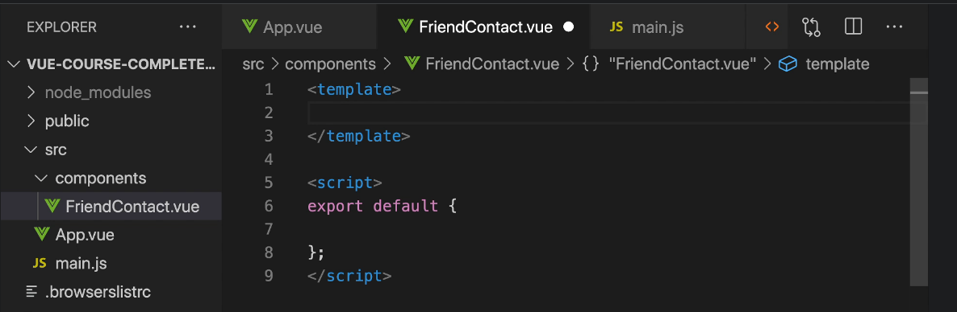

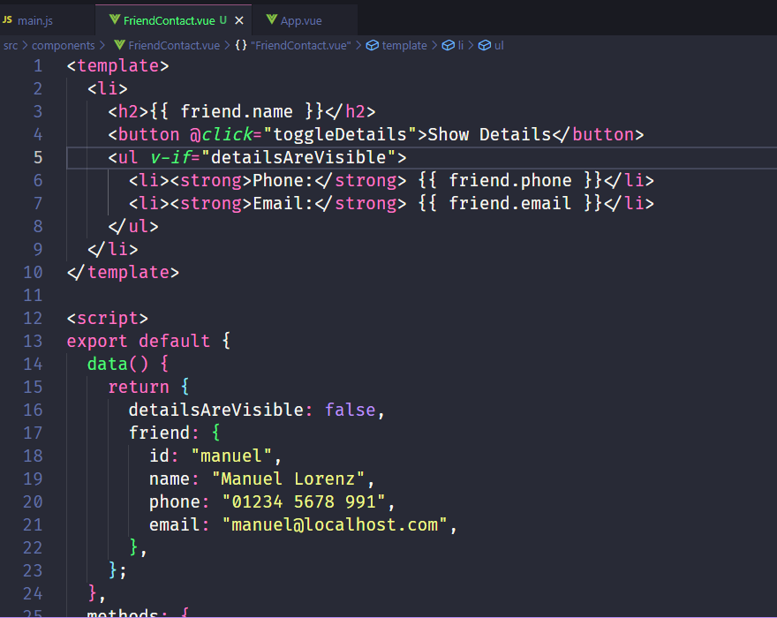

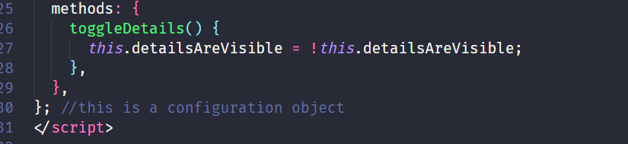

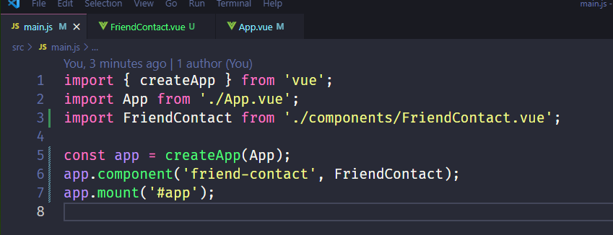

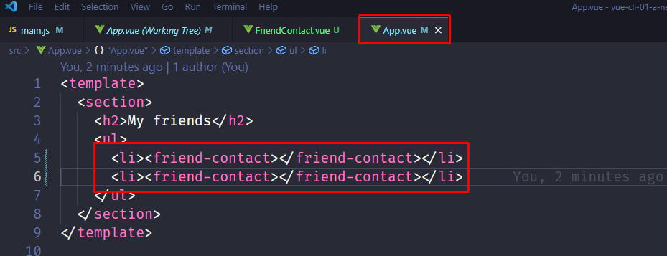

## ADDING A STYLING

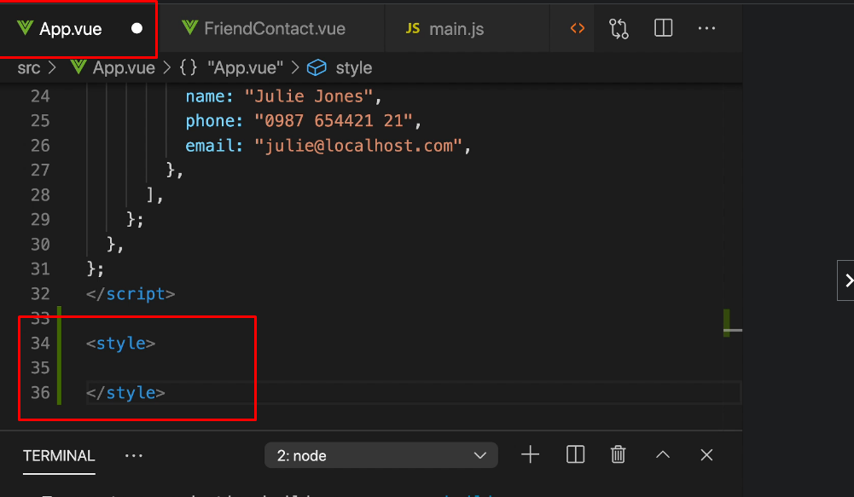

Section 8

## What are props?

Props is a short from properties and you can think of them like a custom html attributes

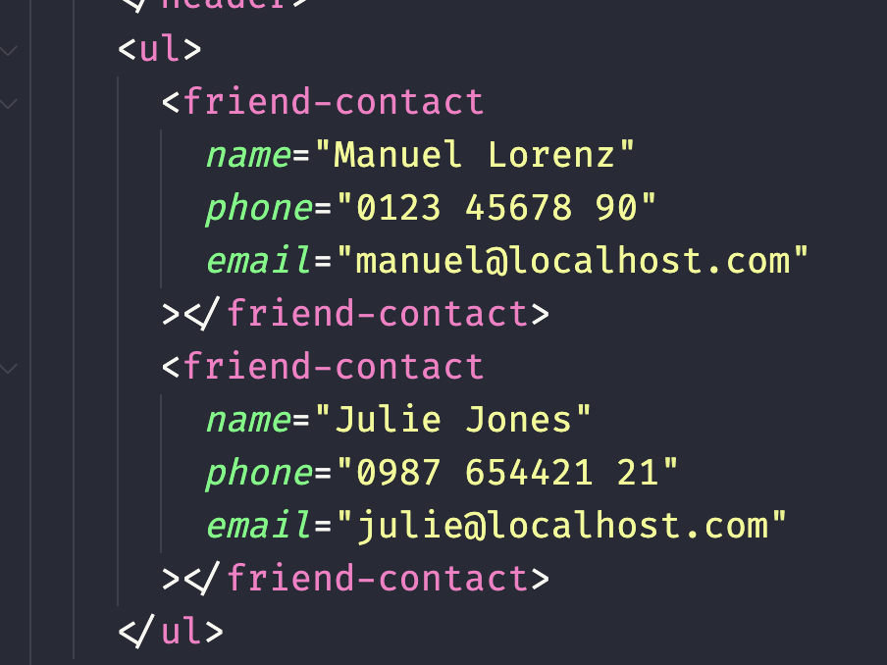

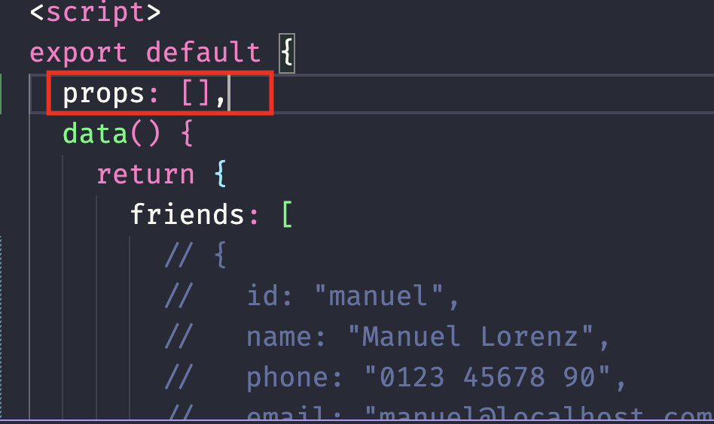

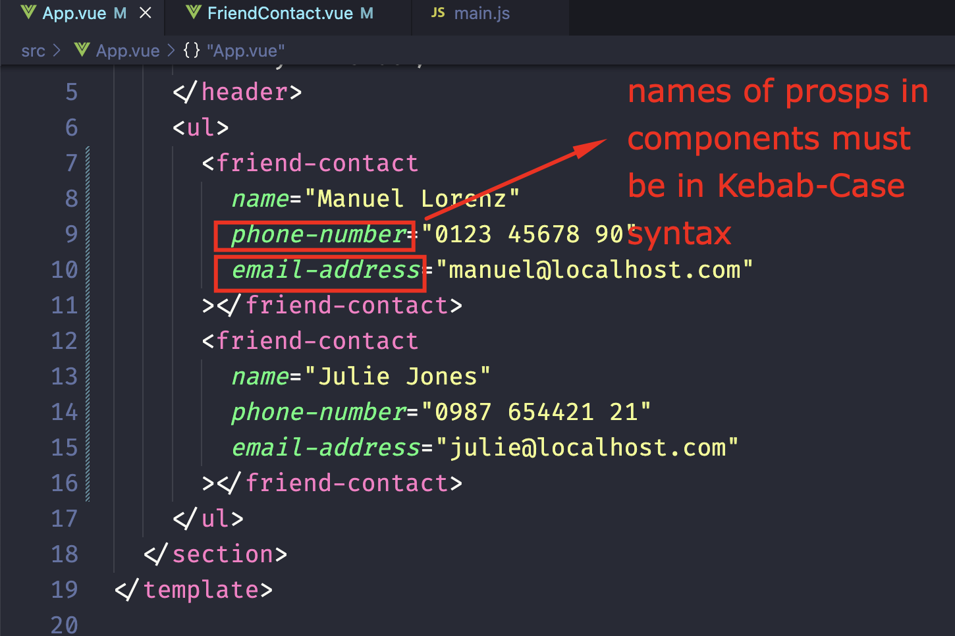

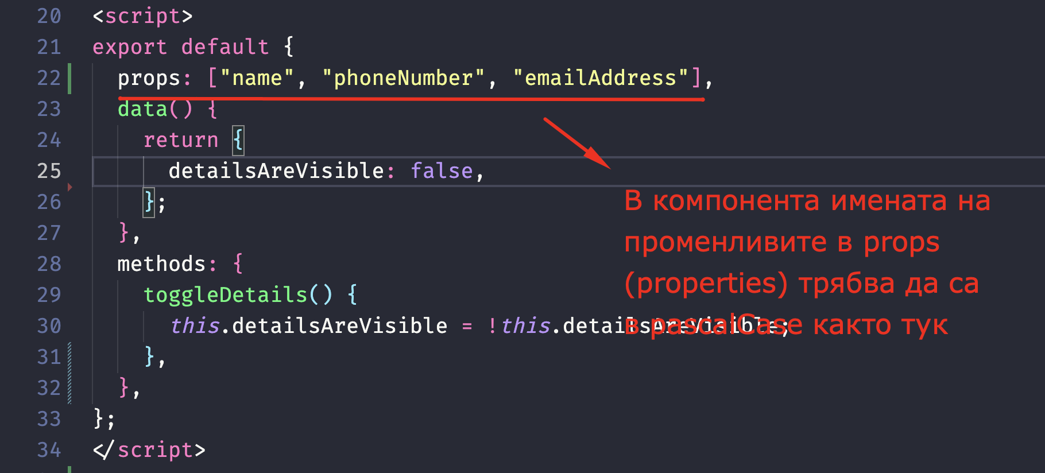

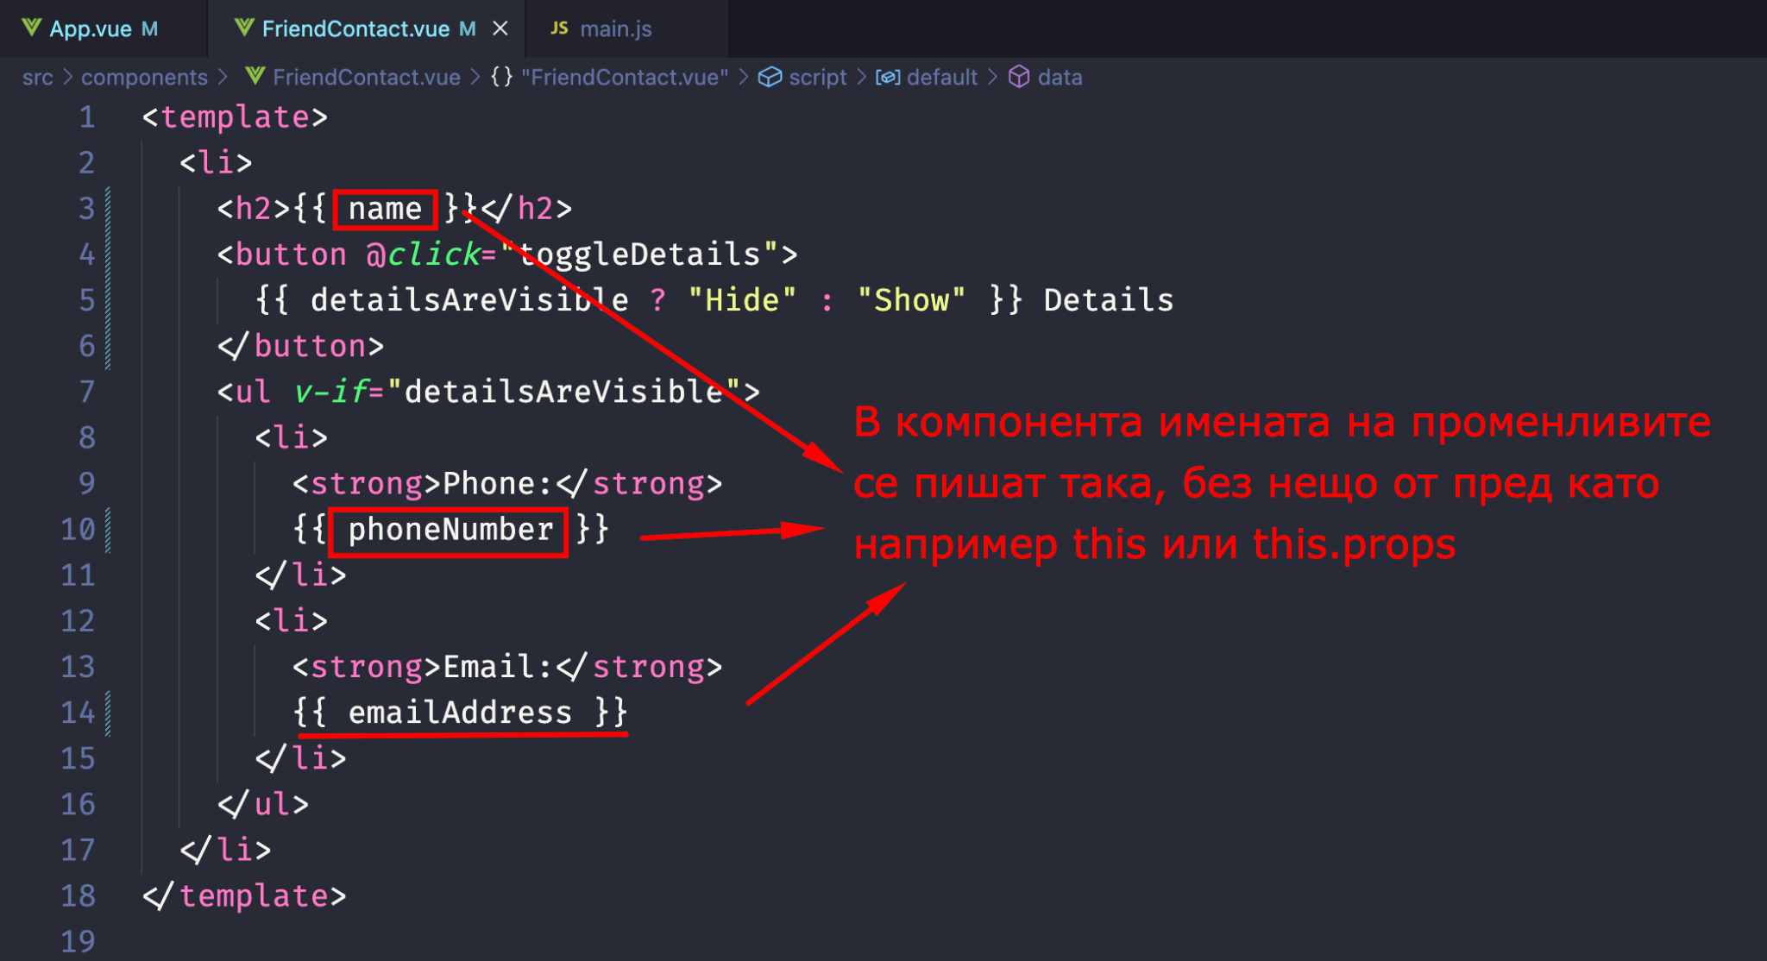

Предните 3 снимки са от компонент FriendContact.vue

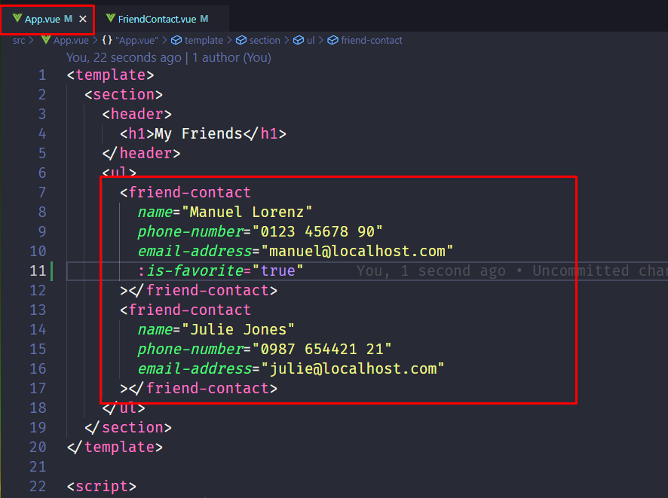

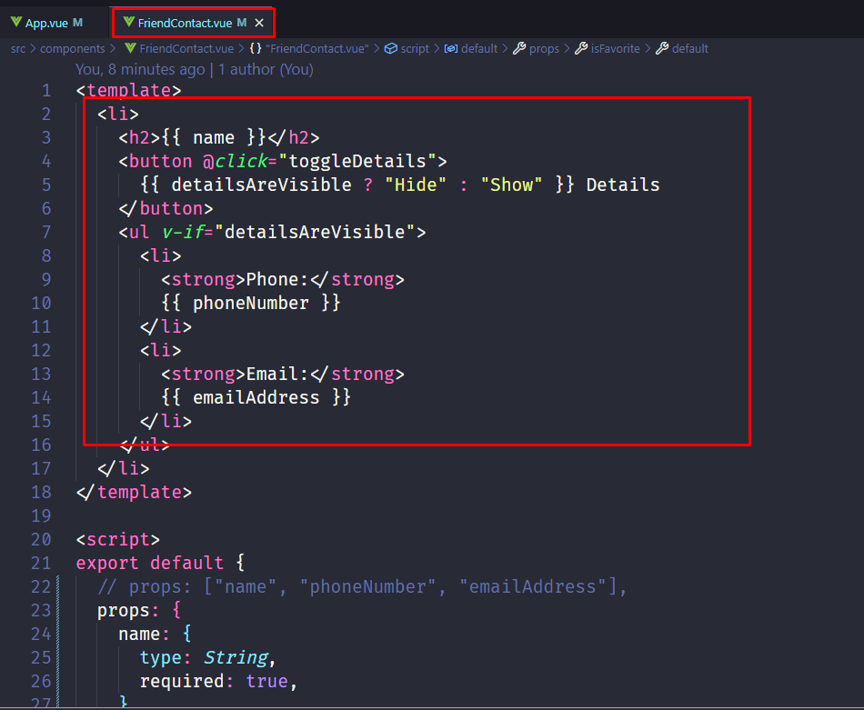  
  
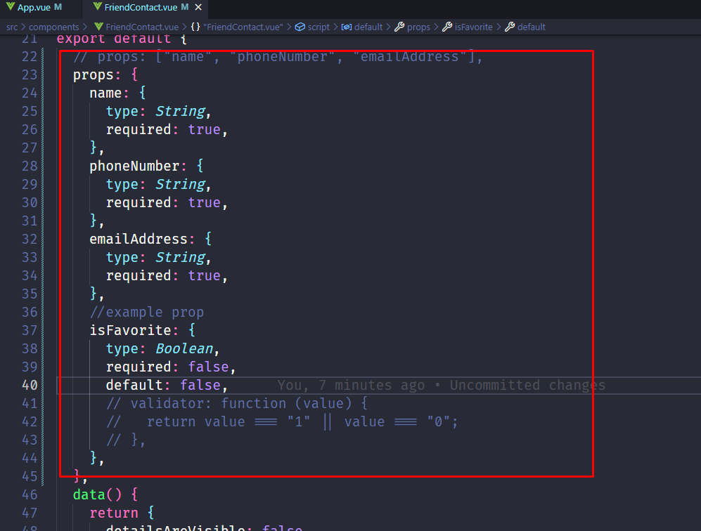

## Emitting Custom Events (Child => Parent Communication)

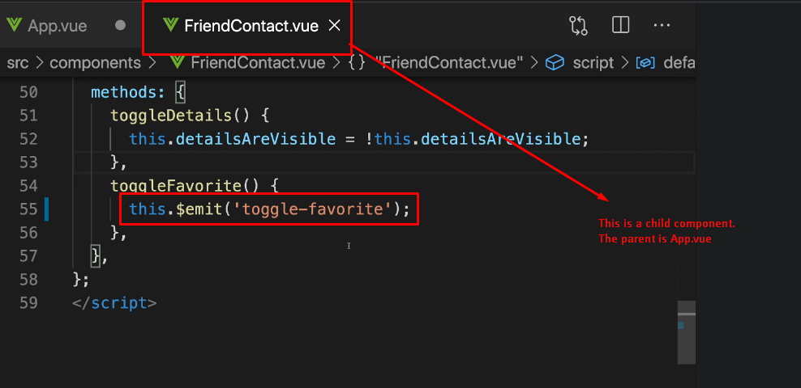

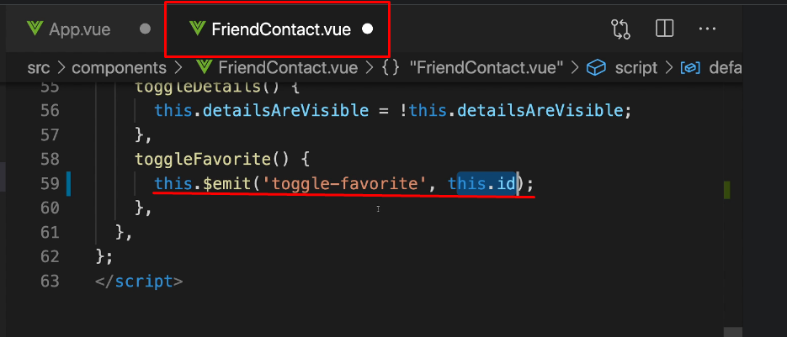

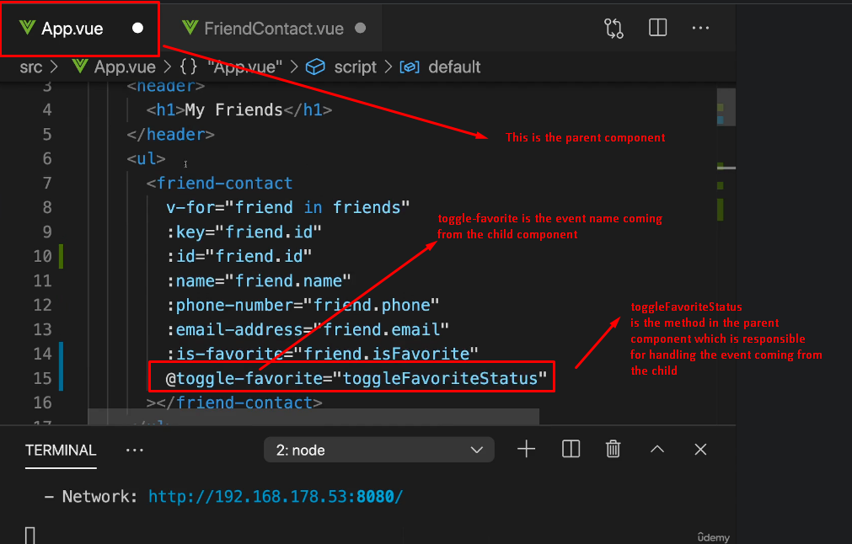

## Defining and validating events

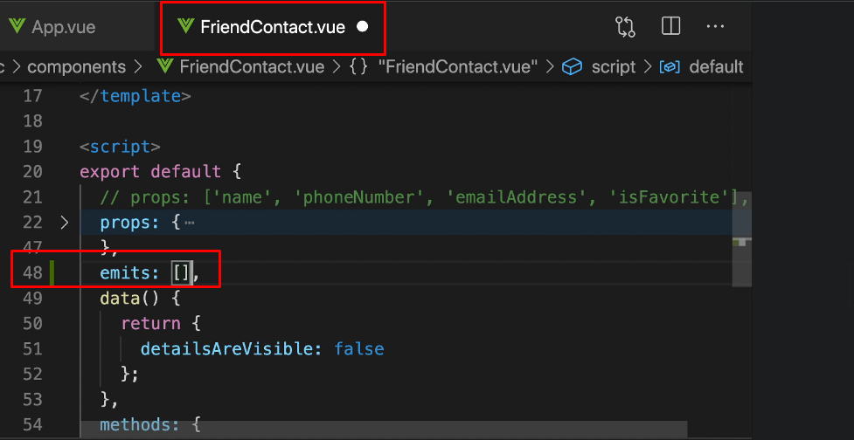

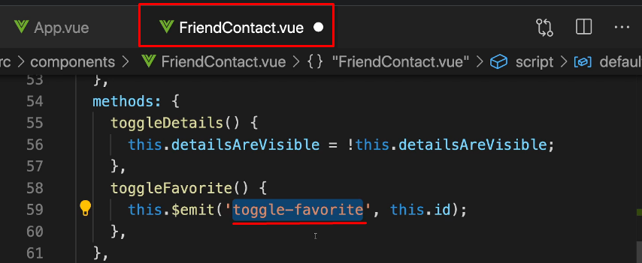

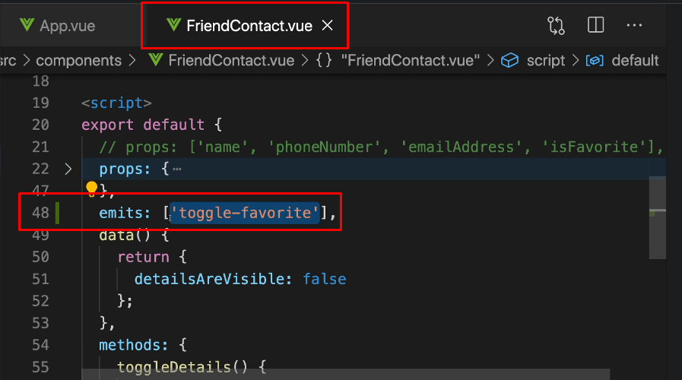

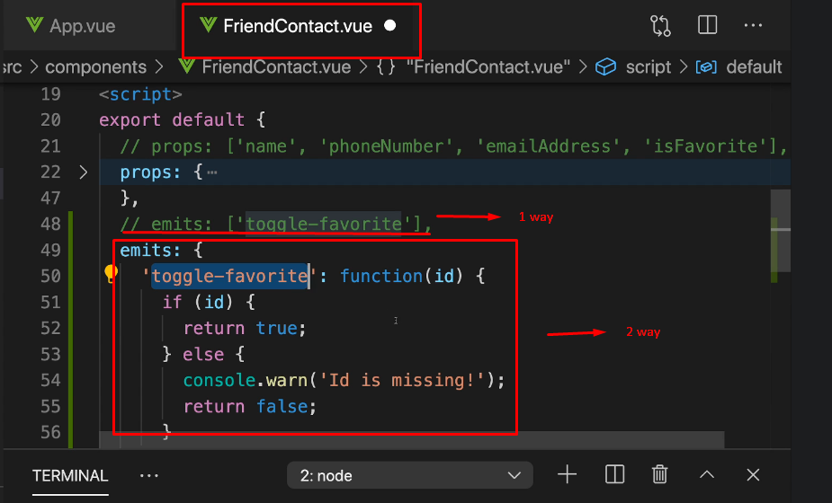

## A Potential Pass-Through Problem /Provide+Inject Vue’s features on help/

This is not necessary a problem but there is other way too. It is when we must pass data trough to many children components, although no every children component used the data. In situations like this one we can use other Vue’s features - provide and inject. It means that we can use data we need somewhere else - in main component for example, and then to provide this data in other component when we need it, not just to pass it trough 5 other components for example.

Step 1 is to provide data like it is shown on the next photos

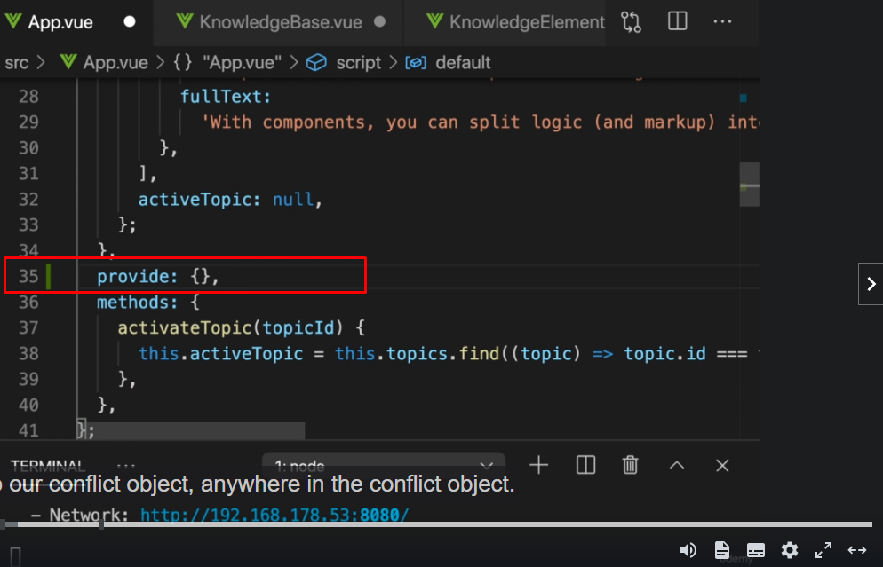

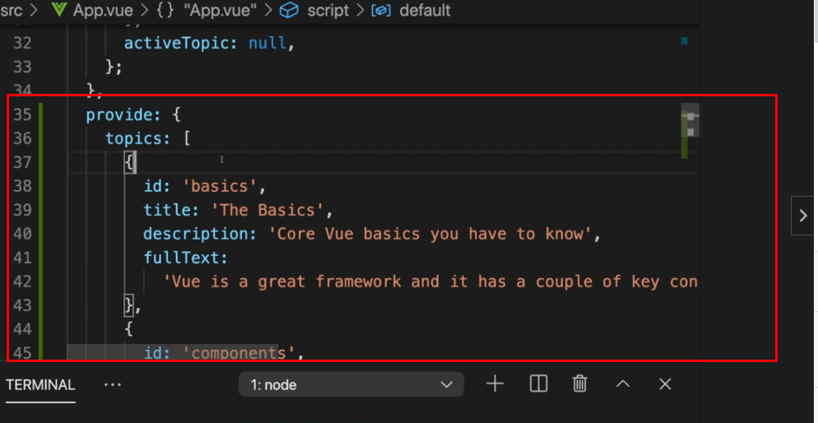

Step 2 is to inject provided data in the component we need it.  
  
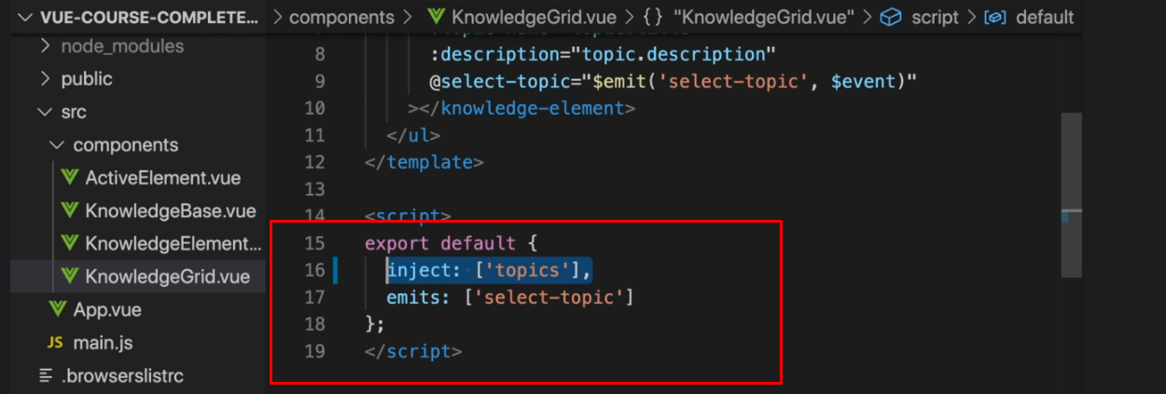

Important note here is that you can inject only what has been provided on a higher-up level. I mean the relationship must be parent-child again. It cannot be done from equal level/neighbor component You cannot inject data which is provided from a neighboor component.

Also to avoid a code duplication we can provide data in the following way

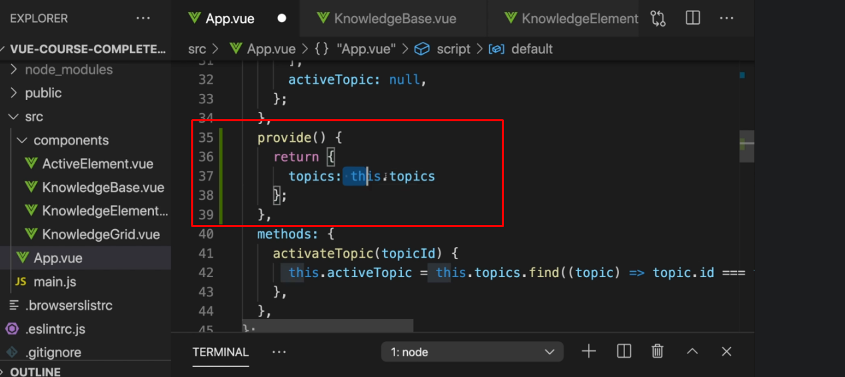

Provide/Inject is very helpful pattern if you want to avoid pass-trough components and passing-trough props unnecessary.

## Provide+Inject for functions/methods

In parent component we provide the function/method  
  
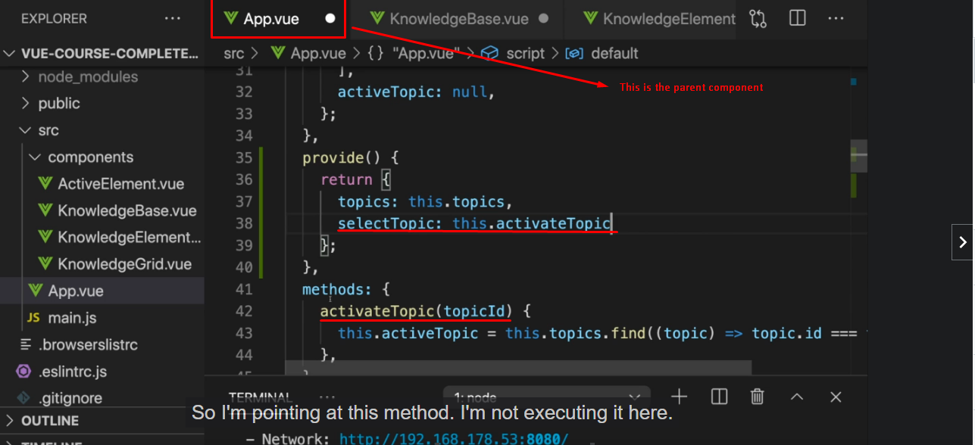  
  
In child component we inject the function/method

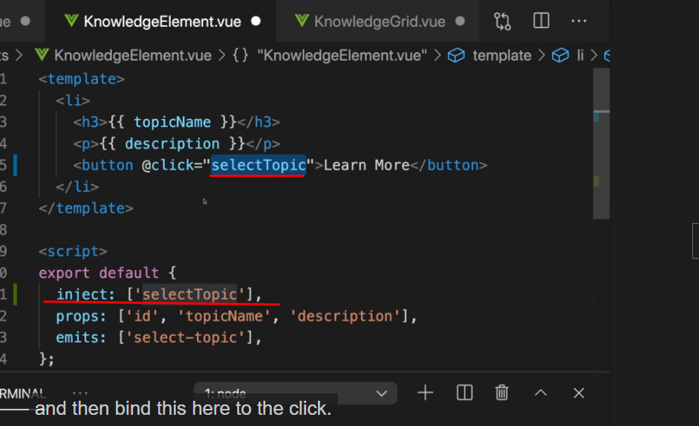

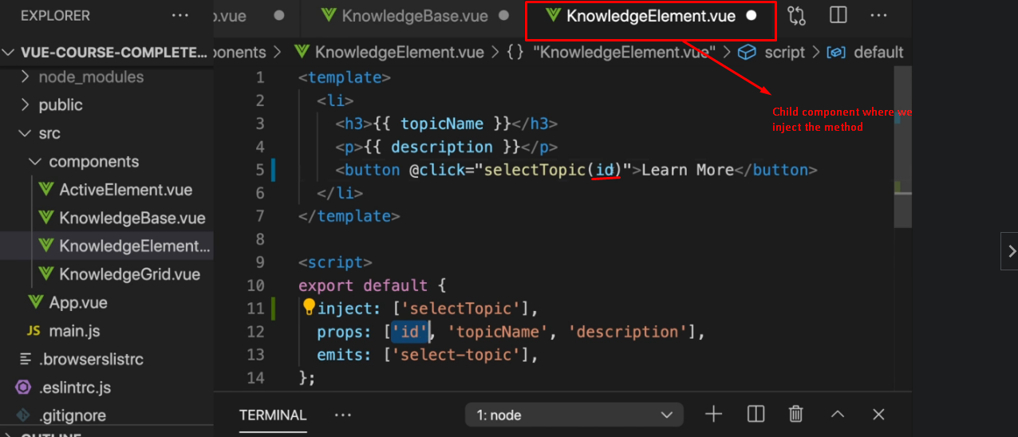

## Section 8 Summary

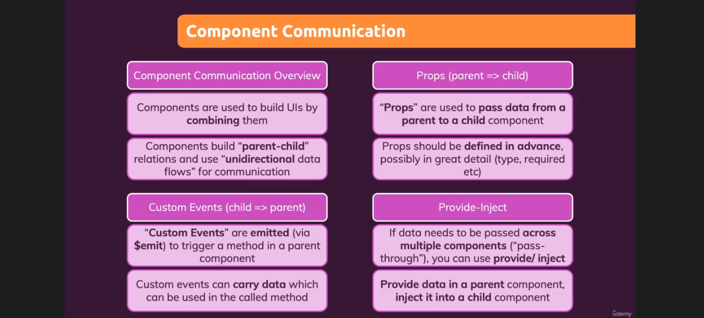

Section 9 Diving Deeper Into Components

## Global VS Local components

Globally registered components

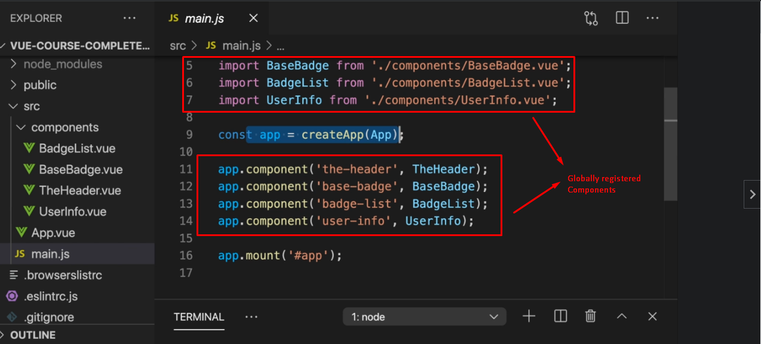

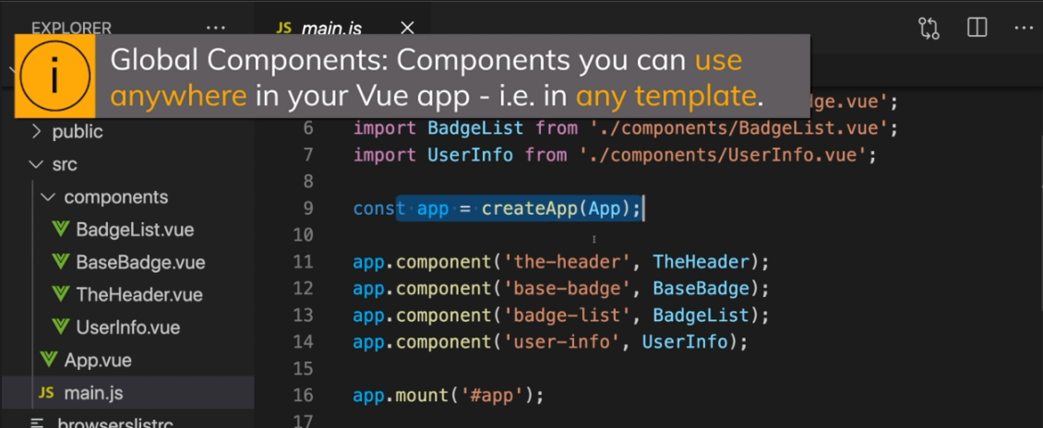

Locally registered component  
  
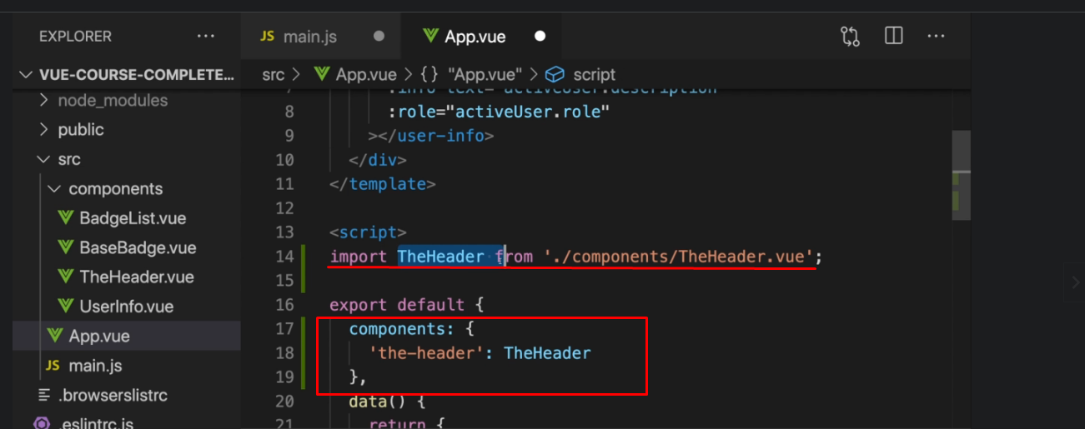

Second way  
  
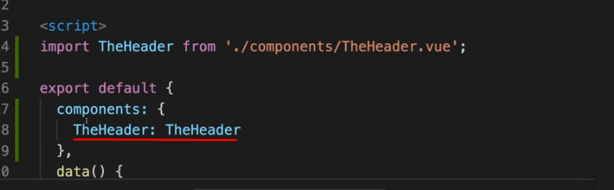

And because of the modern JS syntax it is possible that way too. Just see next image  
  
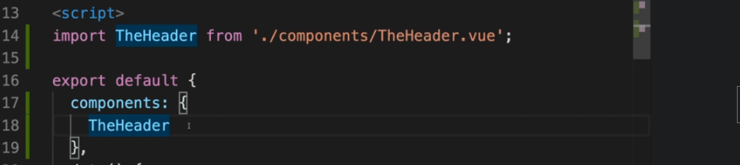

## Scoped Styles

With attribute scoped we limit css in the current component to be local (only for the current component) and not global

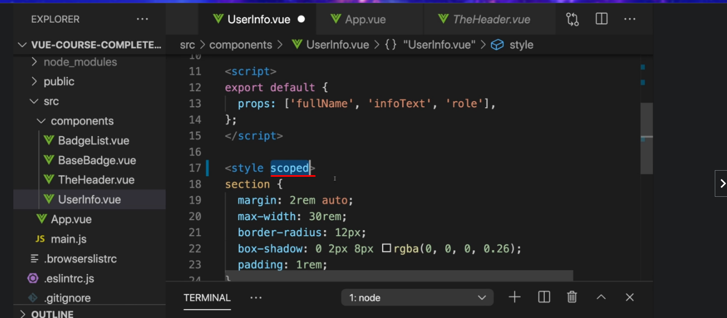

## Slots

Vue has a special syntax for the case when you want to use your own component

as a wrapper around a dynamic content

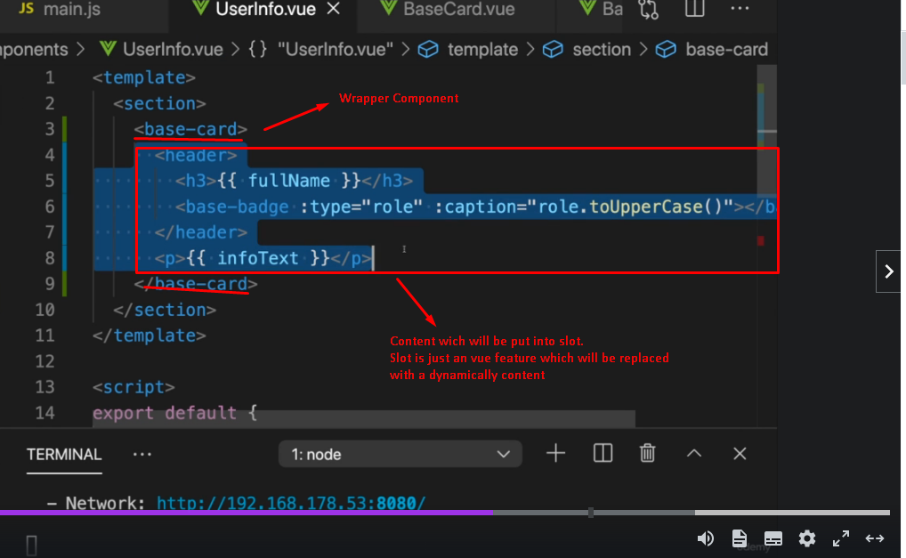

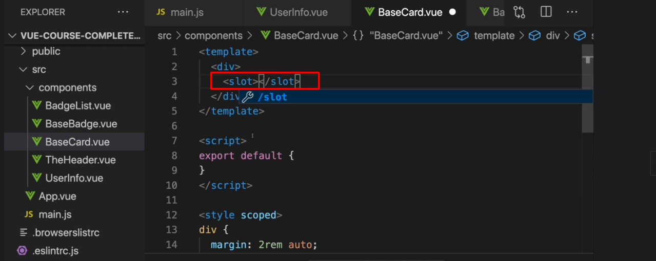

## Named Slots

It is possible your component to have more than one slot (it is shown on the next image) and in that case Vue don’t know where the provided content should go.

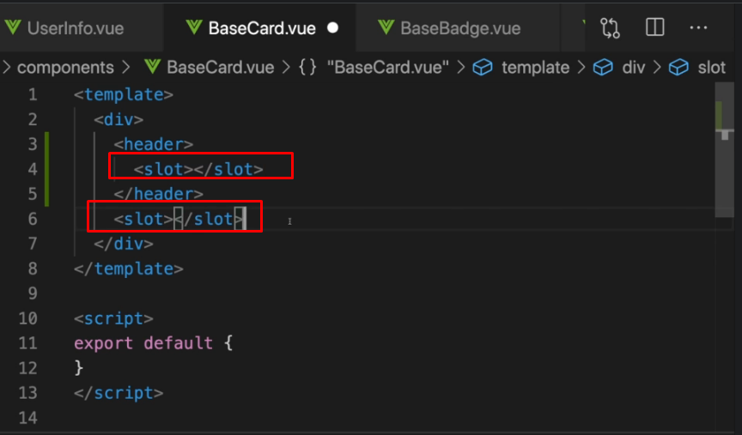

So that’s why if you use more  
than 1 slot you can add names to slots with the name attribute on the slot element.

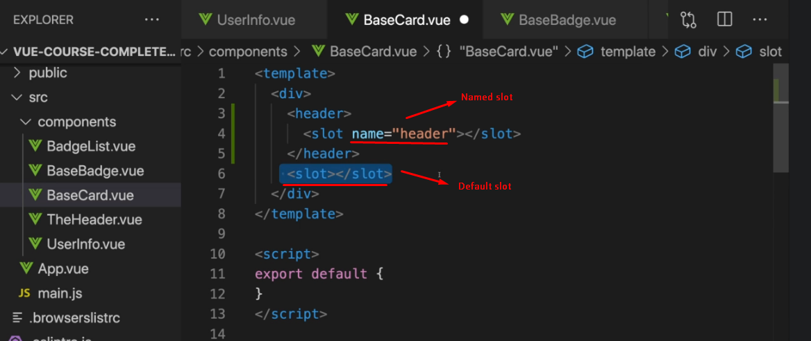

You don’t need to name all slots. If you leave one unnamed slot, that will be the default one. But you must have only one unnamed slot.

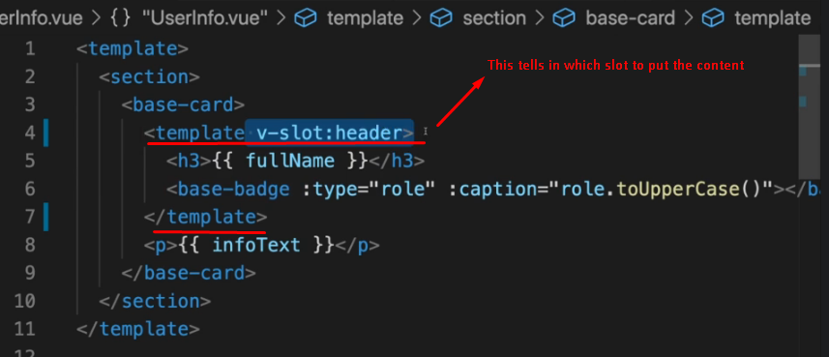

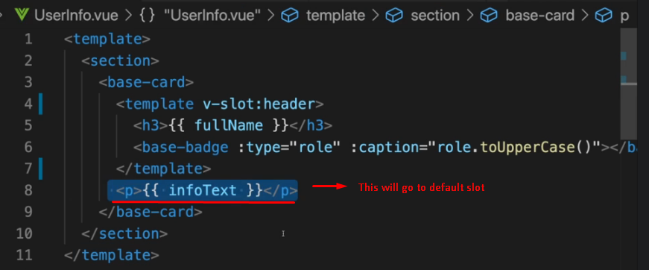

There is one more way to define that the content must go into the default slot  
  
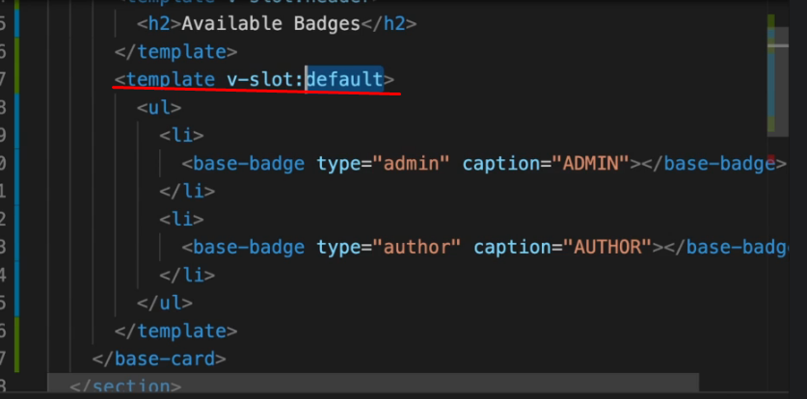

## Default Slot Content

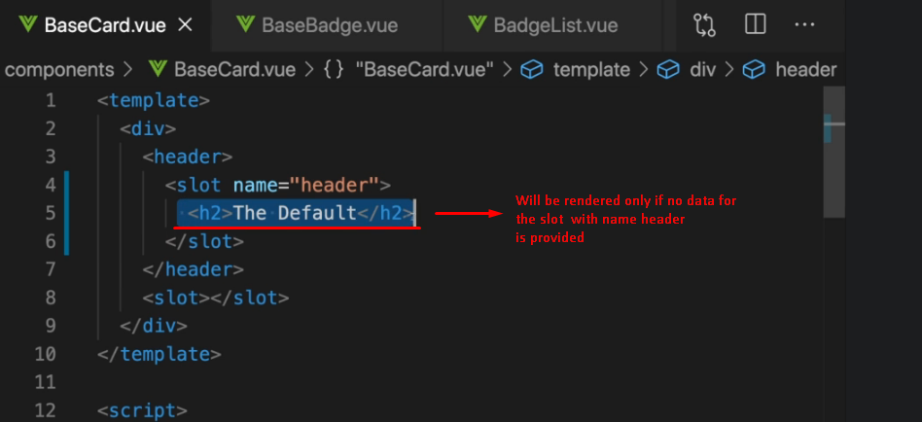

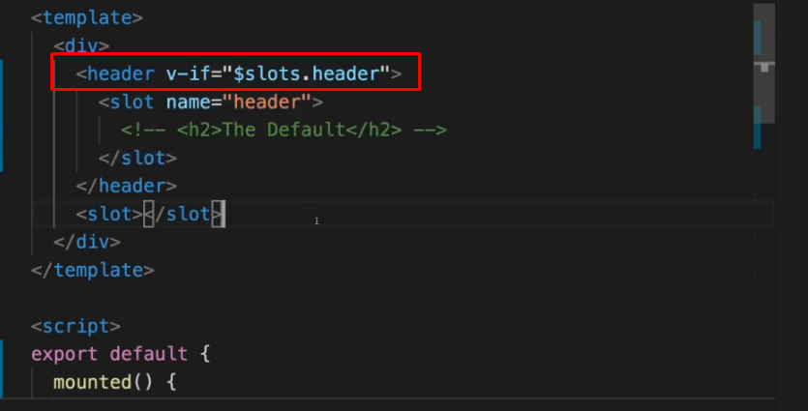

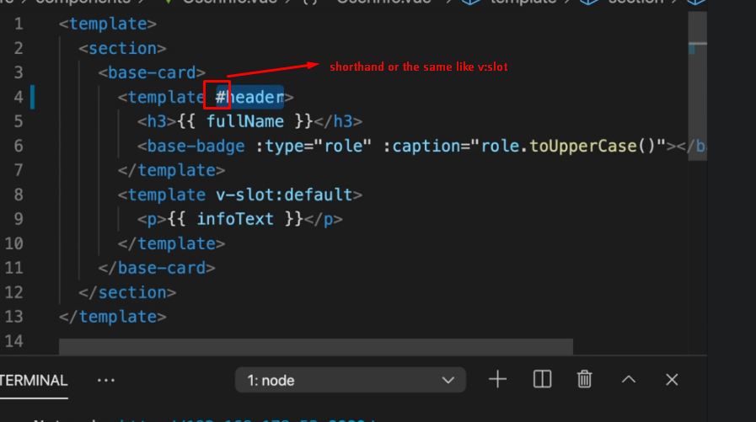

## Scoped Slots

Sometimes if you are building a component wich you might wanna share with other people or colleagues etc… you want to make certain aspects of that component to be customizable, so this the core component could be used in different parts of the app but the content of the list item could be different every time is getting used.

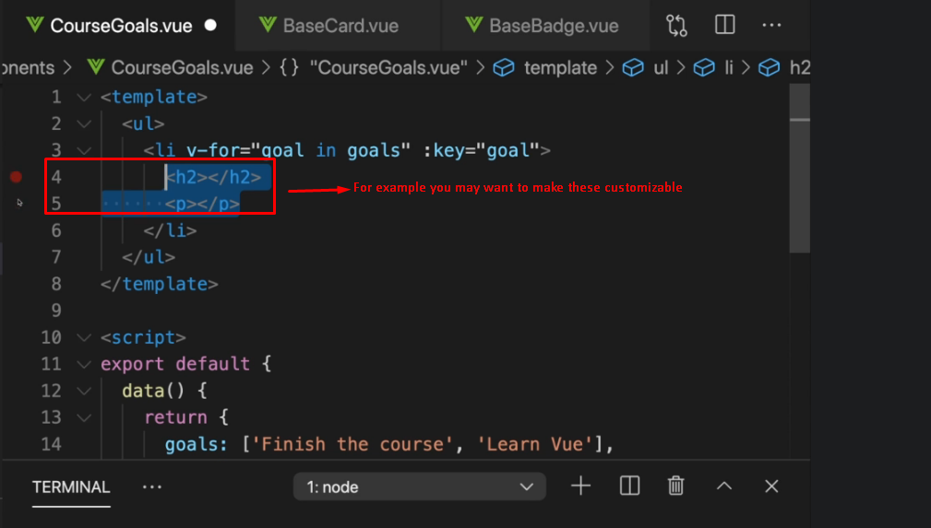

The concept of the scoped slots is about letting you pass data from **inside** the component where you defined a slot   
  
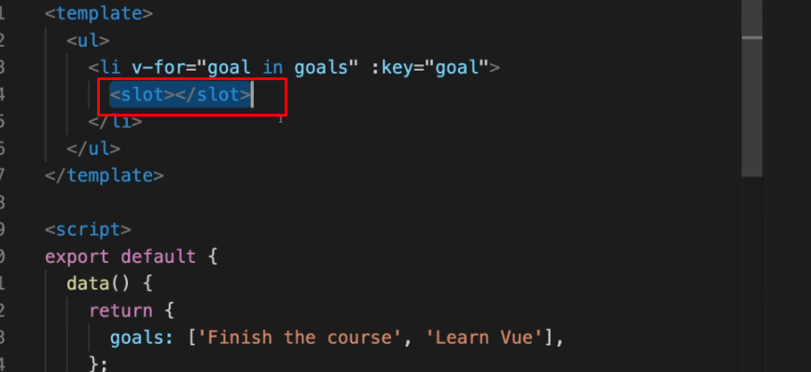

to the component where you pass the markup for the slot.  
  
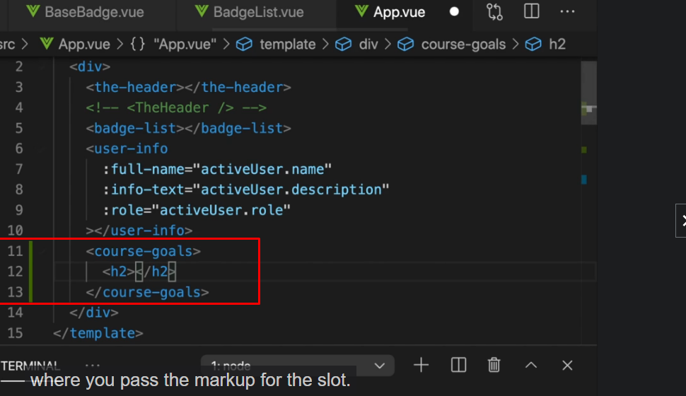

And you do that by going to the component where you have the data and where you define the slot (see ↑ image above) and then on the slot you can add a prop. For example goal but the name is up to you.

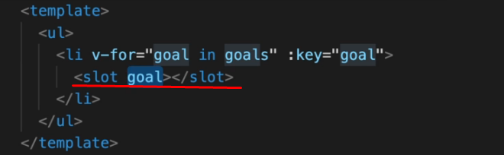

And you can also bind it with v-bind

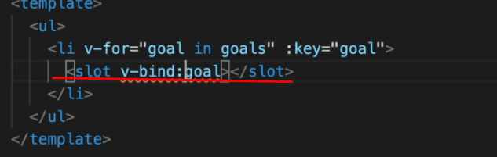

Or shorthand - **<slot :goal=”goal”></slot>**

**The author changes the name of the prop from goal to item to be more clear. See the next image**

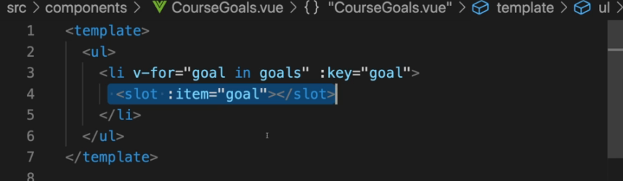

**It is important that whatever you set as props on slot**



**Will now be accessible in the place where you pass data for the slot**

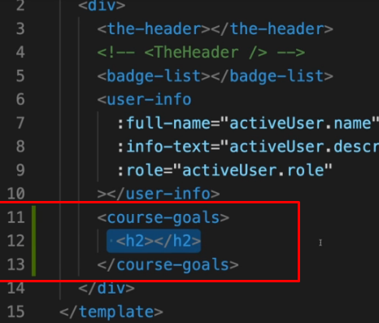

And here we can access the data by adding the template around our slot markup  
  
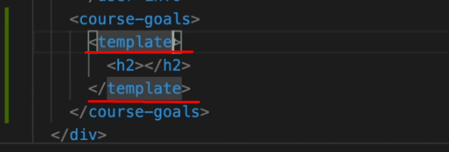

And on the template we use v-slot and now here we can define any name of our choice for example like slotProps but the name is totally up to you. This is just the name of the variable which you can define, which Vue will give you and the value from this variable will always be an object where all the props you define on the slot, are merge in.

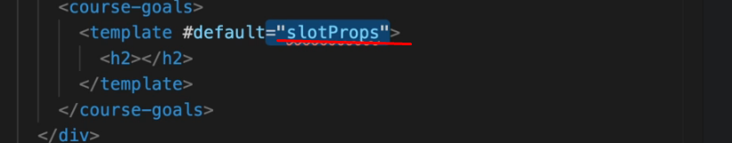

slotProps is just an object containing props data of the slot. In this case it contains data for item and another-prop props.  
  
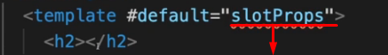  


So, now here we got this slotProps thing and what we can do with it ?

Well, now you can use that inside of the template. For example  
  
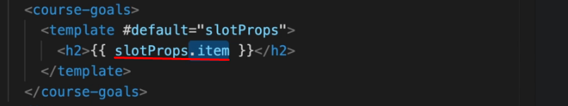

# Dynamic Components

Vue offers you a special html element which you can use - the **component** element

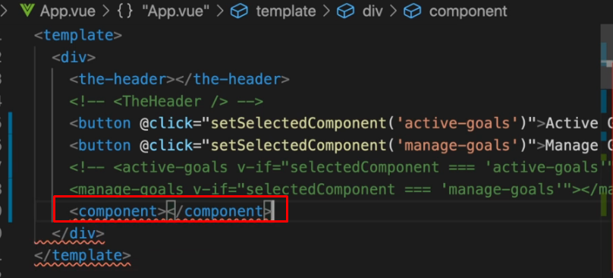

The component doesn’t work stand alone. It will render anything in the browser in the way shown on the photo above ↑ .

It needs one key propert - “**is**” . The **is** property tells which of all your components should be shown in place of this component.

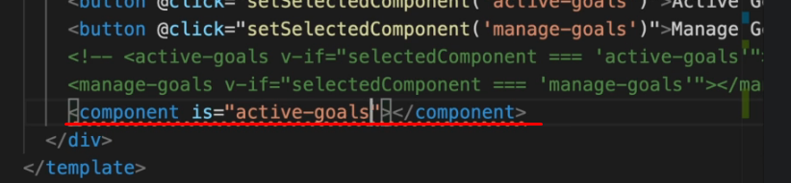

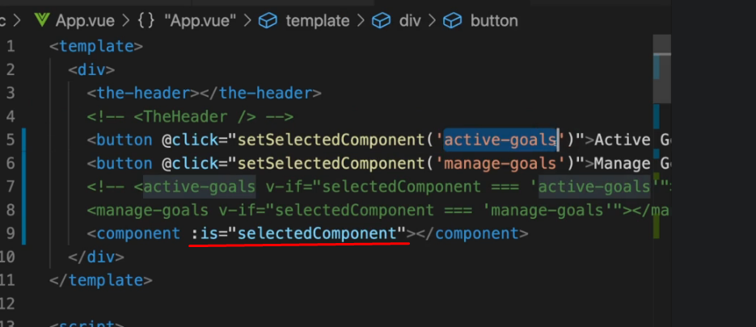

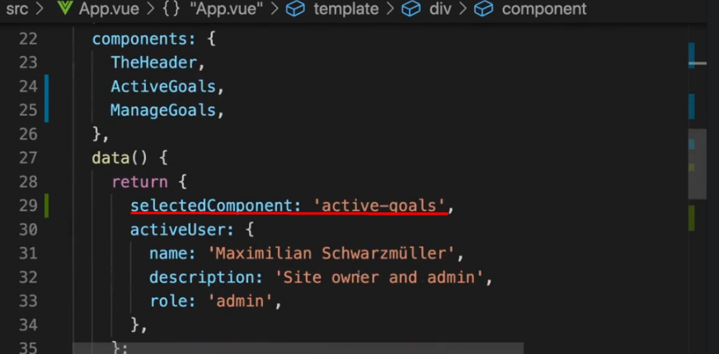

# Keeping Dynamic Components Alive

Keep-alive allows you to tell Vue that the components should not be deleted and removed entirely but that instead their state should be saved. That they should be cached behind the scenes

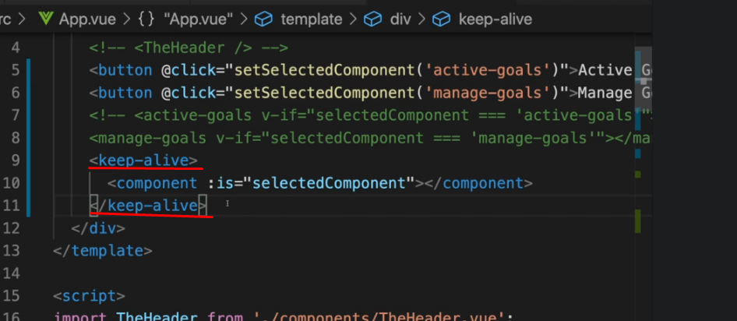  
  
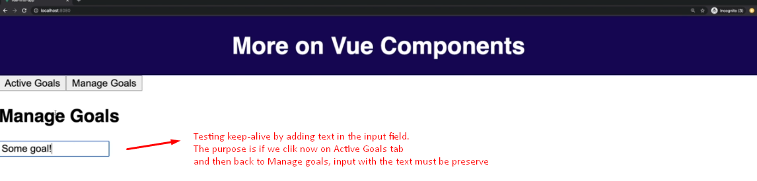

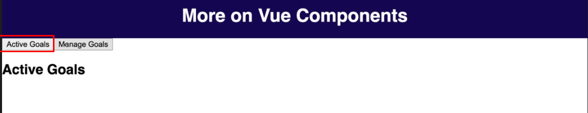

Like you see on the next ↓ image the input with the data inside is are preserved successfully by keep-alive element.

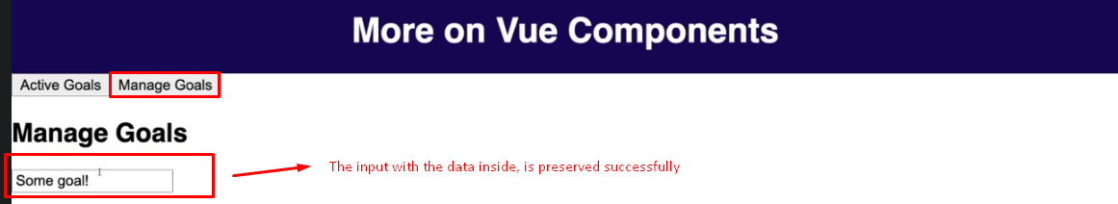

# Applying what we know and a problem

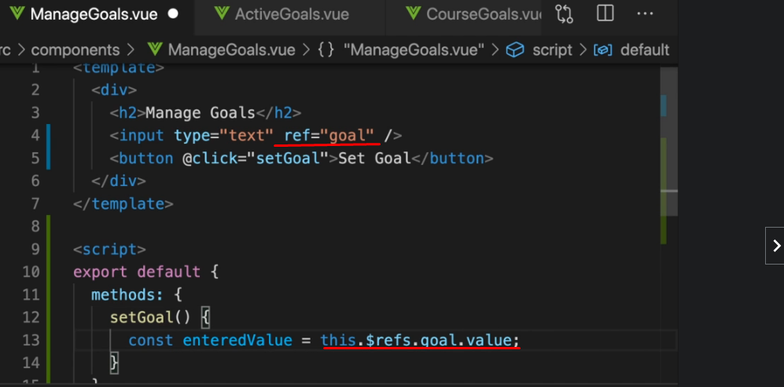

## 

## Making a custom alert

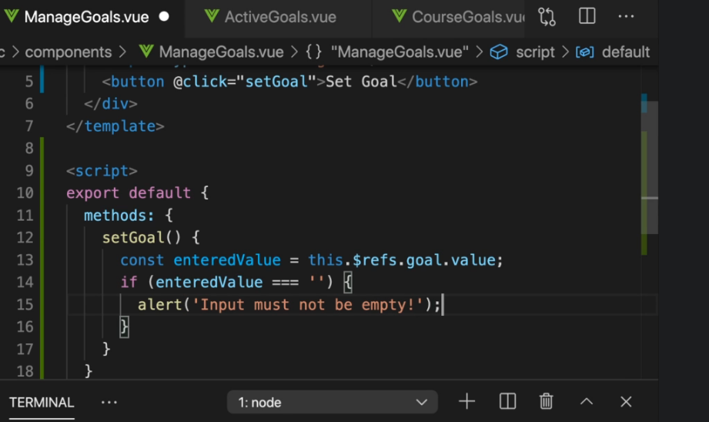

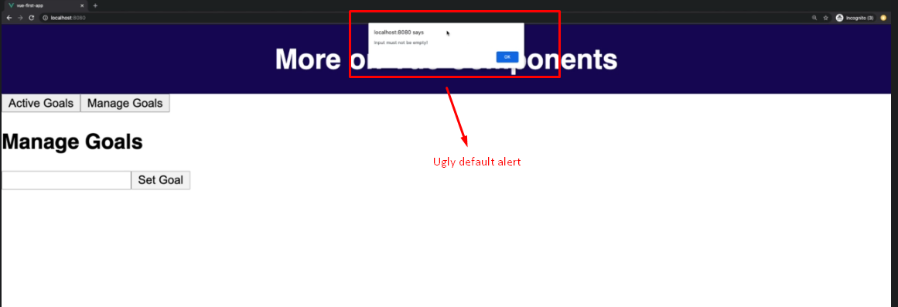

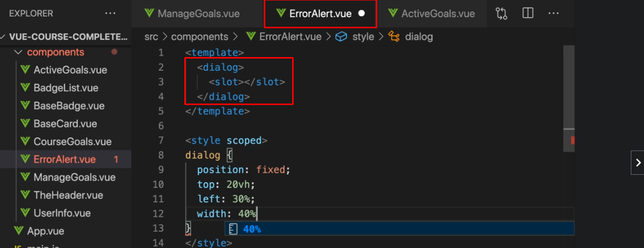

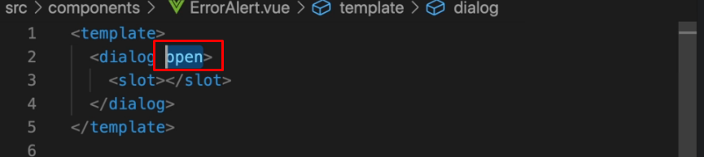

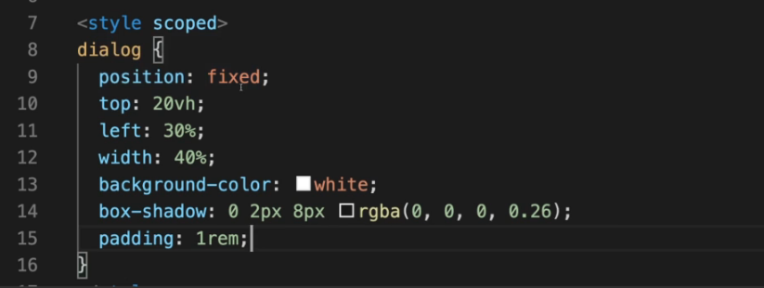

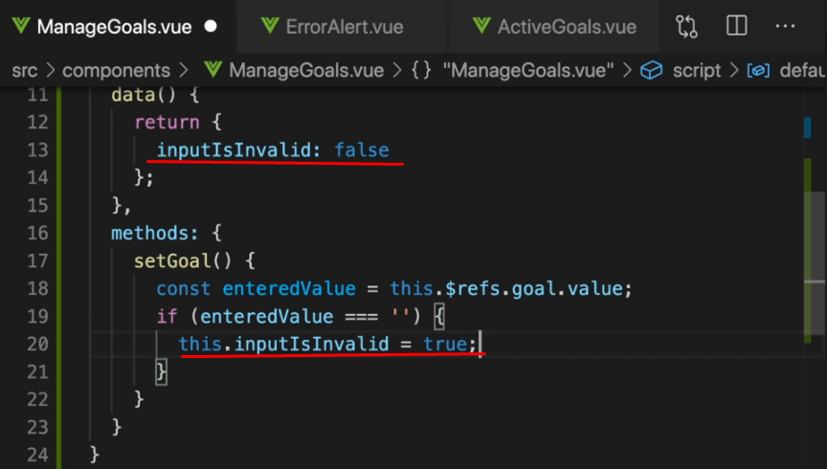

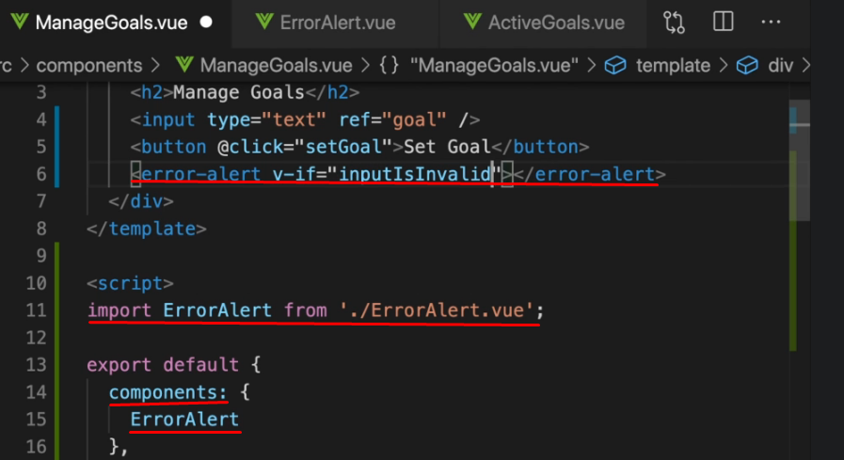

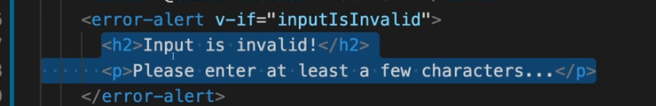

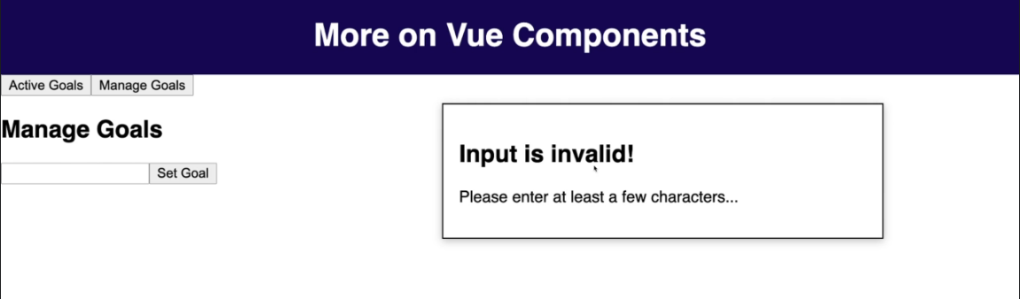

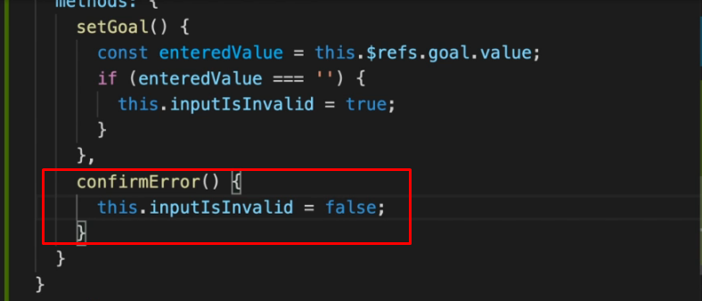

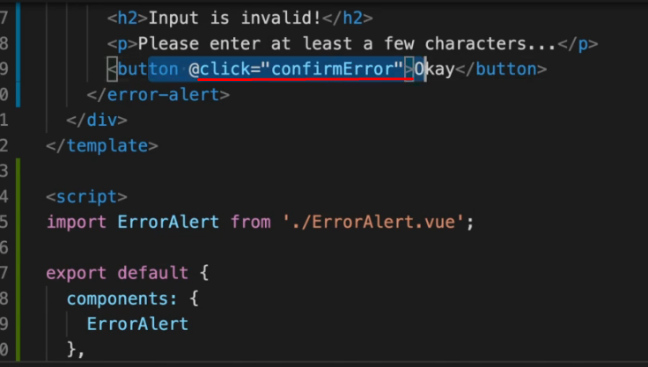

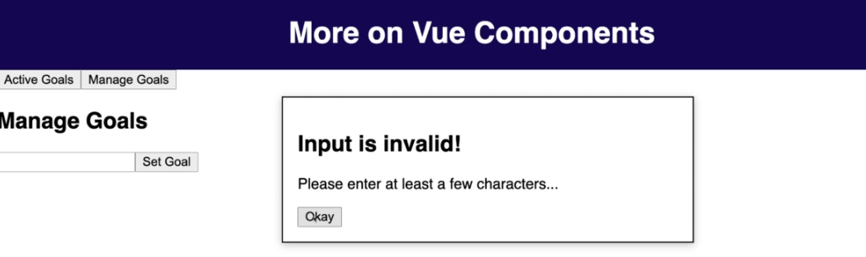

# Teleporting Elements

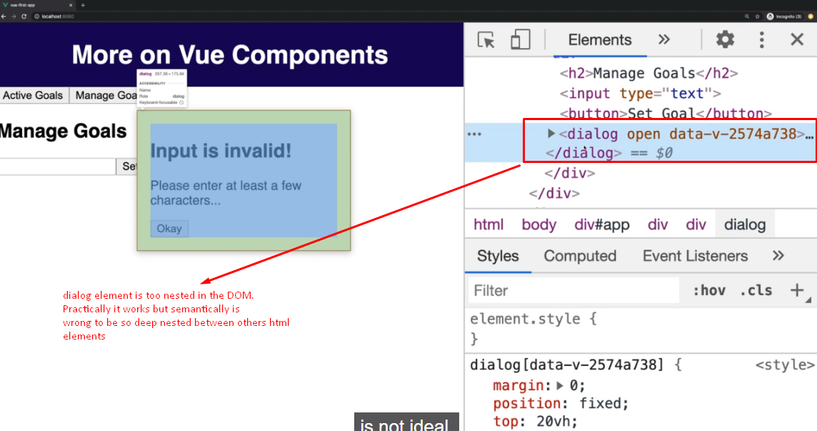

Teleport is built-in Vue component   
  
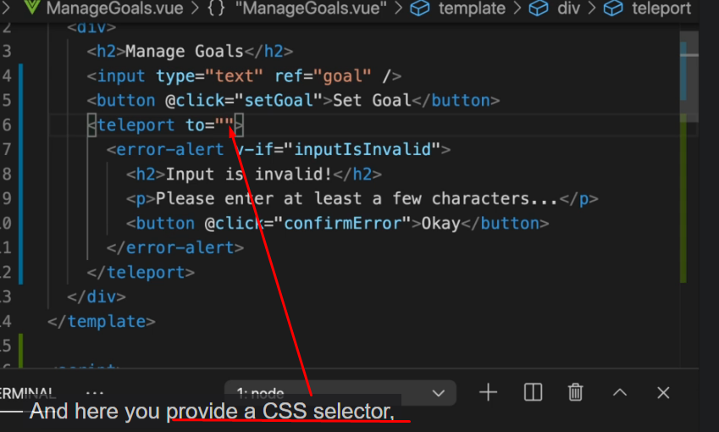  
  
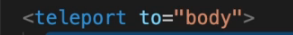  
  
Teleport just tells to Vue where in the dom to render content between teleport tags.